Prepared By:

Chiranjeevi (1401),

S.E.

image001

**IOC_Dev_V5.1.0.4_RedHatLinux_V6.6**

IBM Intelligent Operations Center uses the power of the real-world data that is generated by computer systems by performing the following tasks:

* Collecting and managing the right data
* Integrating and analyzing that data
* Facilitating easy and timely access to information
* Presenting related information in a coherent way

IBM Intelligent Operations Center helps government leaders manage complex city environments, incidents and emergencies with a city solution that delivers operational insights. It offers integrated data visualization, near real-time collaboration and deep analytics to help city agencies enhance the ongoing efficiency of city operations, plan for growth and coordinate and manage response efforts. IBM Intelligent Operations Center provides integrated maps, online dashboards, customizable reports, multiple analytic algorithms, interactive standard operating procedures and other tools for improved city operations and incident or emergency response.

IBM Intelligent Operations Center enables you to:

* Monitor and manage resources, events and incidents through situational awareness.
* Optimize city growth and operations through deep analysis of the city environment and resources.
* Stay connected with citizens and address their concerns through citizen collaboration tools and services.
* Keep citizens safer with crime risk hot-spot analytics.
* Integrate data from various departments and agencies through a common platform.

**Monitor and manage resources, events and incidents**

* Use cross-agency visualization capabilities to give decision makers a near real-time, unified view of city operations so they can make more informed decisions in day-to-day operations as well as times of crises and heightened response.
* View the overall status of city operations in near real-time so the city officials see what resources are needed and available.
* Drill down to get insight into each underlying agency, such as emergency management, public safety, social services, transportation and water.
* Take advantage of near real-time communication and collaboration among city agencies for more effective response management and coordination for disasters, incidents and events.

**Optimize** **city growth and operations**

* Gain more insight into where the city is growing and what factors are contributing to its growth.
* Share centralized information for city-wide integration of daily operations and enable visibility into key performance indicators (KPIs), trends, analyses, business rules and cross-agency collaboration.
* Analyze programs and initiatives against established goals.
* Establish departmental and agency KPIs and monitor them against standard operating procedures that you define.

**Stay connected with citizens and address their concerns**

* Enable citizens to use social and mobile tools to report issues and incidents quickly through the collaboration platform.
* Help reduce some city staffing requirements as more citizens participate and report incidents.
* Notify citizens and businesses directly when issues are addressed, creating more two-way communication and collaboration.
* Combine reported problems with other sources of information to schedule repairs, spot trends and optimize responses.

**Keep citizens safer**

* Help identify the latest trends and predictions for anticipated crimes, enabling city officials to act more proactively.
* Highlight areas of possible criminal activity using hot spots marked on a geo-spatial map.
* See hot spots evolve in near real-time.
* Identify crime patterns to help make more informed decisions.

**Integrate data from departments and agencies**

* Bring data together from various city departments and agencies using one common smarter cities platform.
* Develop custom services using a common platform that provides agencies and developers with access to city-wide data.
* Enable cities with IT resources to deploy software on premise with the security measures they require.
* Enable cities without IT resources to deploy the software as a service in the [IBM SmartCloud](http://www.ibm.com/marketplace/cloud/city-insights/us/en-us) with no upfront capital expense.

**IBM Intelligent Operations Center Architecture:**

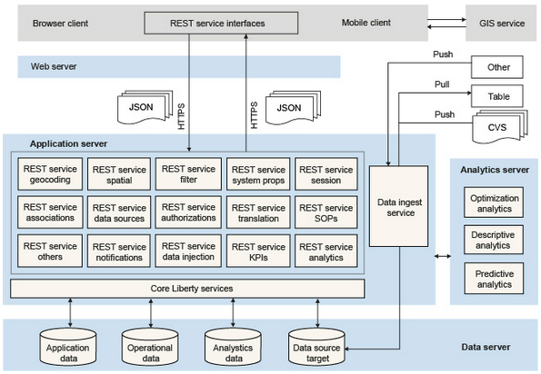

**Prerequisites**:

OS : RedHatLinuxV6.6

RAM : 16GB

HDD : 100GB

Softwares : rhel-server-6.6-x86_64-dvd.iso

ibm-java-x86_64-jre-8.0-1.10.x86_64.rpm

v10.5_linuxx64_expc.tar.gz

ioc_dev_environment_installation.tar.gz

spss_mod_btch_17.0_Lx86_ml.bin

spss_mod_svr_17.0_lx86_ml.bin

SDAP_7.1_Linux64.bin

|  |  |  |  |
| --- | --- | --- | --- |
| **Sl.No** | **fix packs** | **software name** | **Product number** |
| 1 | interim fix: 5.1.0.4-Other-IBMIOC-Multi-PO05947 | ioc_dev_environment_installation.tar.gz | PO05947 |
|  |  |  |  |
| 2 | fix pack: 5.1.0.4-Other-IBMIOC-Multi-PO05780 | IBM_IOC_DevEd_Linux_ML.iso | PO05780 |

**1)Check ip address**

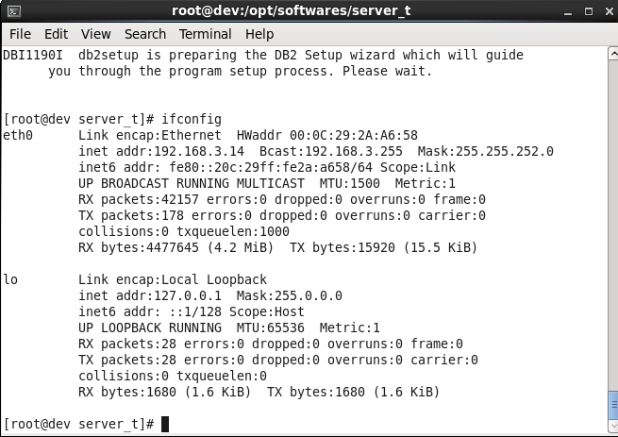

2)Do host mapping

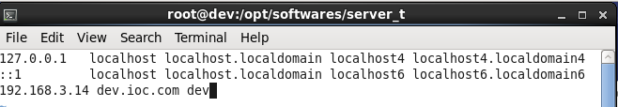

3)Install required libraries

Install the following Red Hat Package Manager (RPM) files that are required by the IBM Intelligent Operations Center installation:

1. Mount the rhel-server-6.6-x86_64-dvd.iso file to the system.   
2. Select open a terminal window as a root.  
3. Execute the commands:   
[root@localhost]# mkdir /mnt/cdrom  
[root@localhost]# mount -o ro /dev/cdrom /mnt/cdrom  
4. Create the text file server.repo in the /etc/yum.repos.d directory.   
Note: To use gedit, execute the command:

[root@localhost]# gedit /etc/yum.repos.d/server.repo  
Add the following text to the file:   
  
[server]  
name=server  
baseurl=file:///mnt/cdrom/   
enabled=1  
  
where baseurl depends on the mounting point and the RHEL distribution.   
  
In the example, the mounting point is cdrom and the RHEL distribution is Workstation but could be sever.  
  
5. Execute the command:  
[root@localhost]# yum clean all  
6. Execute the command to import related public keys:  
[root@localhost]# rpm --import /mnt/cdrom/*GPG*  
7. Execute the commands to install the required libraries:  
[root@localhost]# yum install gtk2.i686  
[root@localhost]# yum install libXtst.i686  
If you received the missing libstdc++ message above, install the libstdc++ library:  
[root@localhost]# yum install compat-libstdc++  
yum install the following libraries as well

* yum install audit-libs.i686
* yum install audit-libs.x86_64
* yum install compat-libstdc++*i686
* yum install dos2unix.x86_64
* yum install gettext.x86_64
* yum install glibc.i686
* yum install glibc.x86_64
* yum install ksh.x86_64
* yum install libaio.i686
* yum install libaio.x86_64
* yum install libgcc.i686
* yum install libgcc.x86_64
* yum install libstdc++.i686
* yum install nss-softokn-freebl.i686
* yum install nss-softokn-freebl.x86_64
* yum install ntp.x86_64
* yum install openssh-clients.x86_64 pam.i686
* yum install pam-devel.i686
* yum install pam_passwdqc.x86_64
* yum install tcsh.x86_64 unzip.x86_64
* yum install xorg-x11-xauth.x86_64
* yum install zlib.i686 zlib.x86_64
* yum install gtk2.i686 gtk2.x86_64
* yum install gtk2-engines.i686
* yum install gtk2-engines.x86_64 libXtst.i686
* yum install libXtst.x86_64
* yum install nfs-utils
* iscsi-initiator-utils

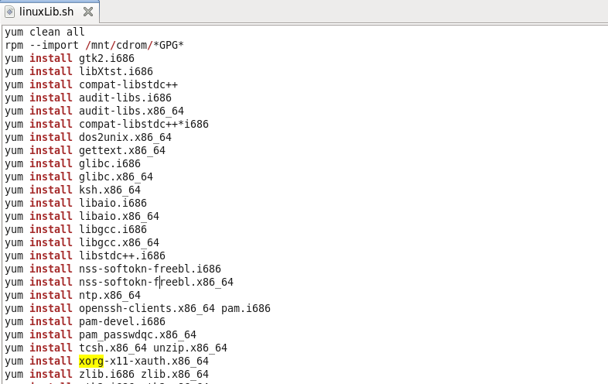

1. Open a terminal window, and log on as a root user.
2. Define a fully qualified name and short host name either by using a DNS server, or by creating a definition in the /etc/hosts file.

Note: Ensure that the database server host name is not the same as either of the following database names:

* + IOCDB
  + IOCDATA

1. Ensure that the HOSTNAME value that is defined in the /etc/sysconfig/network file is set to the short host name, and that it is not set to the fully qualified host name. For example, set HOSTNAME=xyz instead of HOSTNAME=xyz.yourco.com.

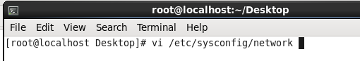 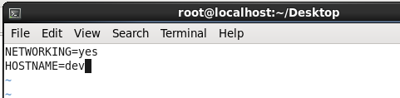

1. Verify that the host name, fully qualified host name, and domain name are configured correctly on each server:
   * Enter the following command: hostname -s. The verification is successful if the command returns the defined short host name for the server.
   * Enter the following command: hostname -f. The verification is successful if the command returns the fully qualified domain and host name for the server.
   * Enter the following command: hostname -d. The verification is successful if the command returns the domain name of the server.
2. In the /etc/selinux/config file, configure the SELinux setting to either permissive or disabled. For example, to configure the SELinux setting to permissive, in the /etc/selinux/config file, edit the SELinux setting as shown in the following example and then restart the server:

SELINUX=permissive

Note: The SELinux setting must not be enabled.  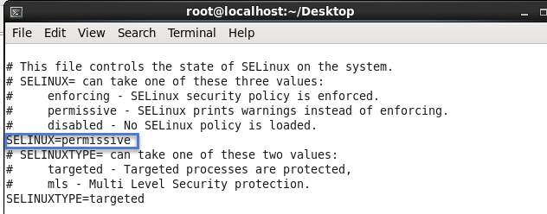

1. Reboot the operating system using the following command to make the SELinux changes effective:

reboot

1. To disable the server firewalls, enter the following commands:

service iptables save

service iptables stop

chkconfig --level 123456 iptables off

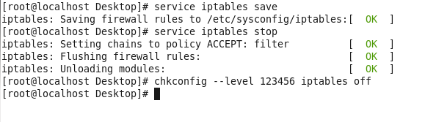

1. To install the prerequisite RPM files, enter the following command:

yum install -y audit-libs.i686 audit-libs.x86_64 compat-libstdc++*i686 compat-libstdc++_*x86_64 dos2unix.x86_64 gettext.x86_64 glibc.i686 glibc.x86_64 ksh.x86_64 libaio.i686 libaio.x86_64 libgcc.i686 libgcc.x86_64 libstdc++.i686 nss-softokn-freebl.i686 nss-softokn-freebl.x86_64 ntp.x86_64 openssh-clients.x86_64 pam.i686 pam-devel.i686 pam_passwdqc.x86_64 tcsh.x86_64 unzip.x86_64 xorg-x11-xauth.x86_64 zlib.i686 zlib.x86_64 gtk2.i686 gtk2.x86_64 gtk2-engines.i686 gtk2-engines.x86_64 libXtst.i686 libXtst.x86_64 nfs-utils 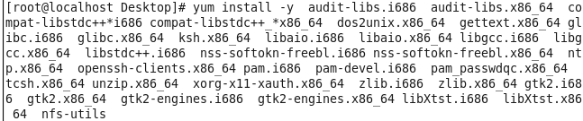

1. Install the Red Hat Enterprise Linux packages for the X Window System on the analytics, application, and web servers.

X Windows is not required for the initial installation of IBM Intelligent Operations Center, but it is required if you want to update the underlying IBM products by using IBM Installation Manager. For example, you can update WebSphere® Application Server Liberty Profile and IBM HTTP Server. You can install either the GNU Object Model Environment (GNOME) desktop or the K Desktop Environment (KDE) desktop to use with IBM Installation Manager.

Note: DB2® does not use the IBM Installation Manager, so the data server does not require the graphical user interface (GUI) that is provided by either the GNOME desktop or the KDE desktop.

1. Choose one of the following options:
   * To install the GNOME desktop, enter the following command:

yum -y groupinstall "X Window System" Desktop 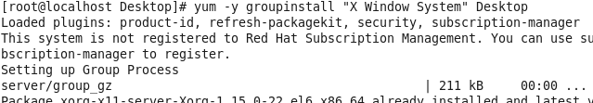

* + To install the KDE desktop, enter the following command:

yum -y groupinstall "X Window System" "KDE Desktop" 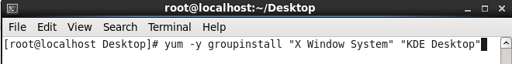

1. Enter the following command: yum -y update 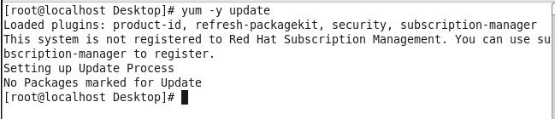
2. To start the desktop, enter the following command: init 5
3. To configure the GUI desktop to be the default desktop, edit the /etc/inittab file and change the value of the initdefault property from 3 to 5. The following example shows the updated line:

id:5:initdefault: 

1. Save the changes, and then restart the server.

4)Install Java Runtime Environment

Command: rpm -ivh /installmedia/*downloaded_JAVA_RPM_filename*

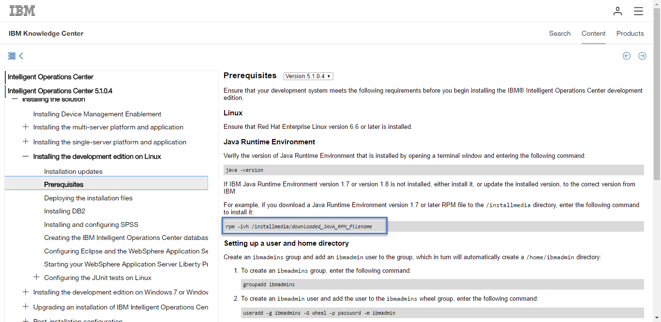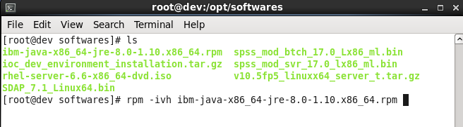

5)Set java path

Set java path in .bash_profile in /root/.bash_profile 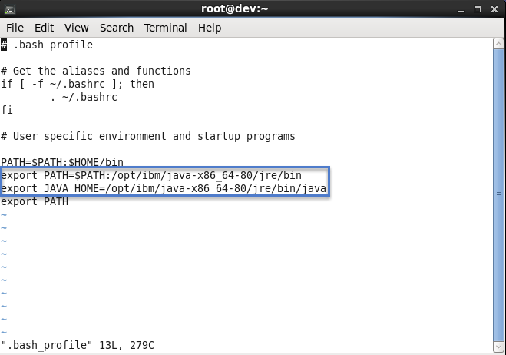

6)Run .bash_profile

Command: . .bash_profile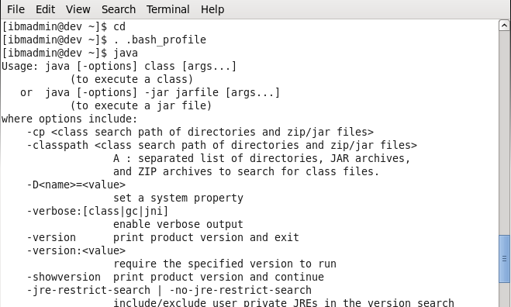

**7)** **Setting up a user and home directory**

Create an ibmadmins group and add an ibmadmin user to the group, which in turn will automatically create a /home/ibmadmin directory:

1. To create an ibmadmins group, enter the following command:

groupadd ibmadmins

1. To create an ibmadmin user and add the user to the ibmadmins wheel group, enter the following command:

useradd -g ibmadmins -G wheel -p password -m ibmadmin

1. To enable sudo for the ibmadmins wheel group and, therefore, also for theibmadmin user, enter the following command:

sed -i -- 's/# %wheel/%wheel/g' /etc/sudoers

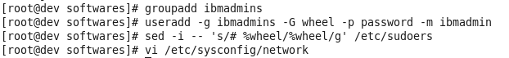

Log on as the ibmadmin user to extract the installation files, and to run Eclipse.

Note:Reset ibmadmin password if ibmadmin user authentication failed 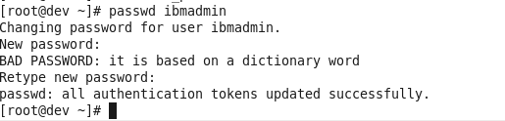

# 8) Deploying the installation files

The ioc_dev_environment_installation.tar.gz file includes Eclipse, theEclipse workspace, and WebSphere® Application Server Liberty Profile run time. Install all three components into the /home/ibmadmin directory.

## Procedure

1. Log on as the ibmadmin user.
2. If you are upgrading a previous version of IBM Intelligent Operations Center, archive the following directories that are in the /home/ibmadmin directory.
   * eclipse
   * liberty
   * workspaces

After you complete the upgrade, you can reapply any updates that you made to the server.xml file or other files in the previous installation.

1. Extract the contents of the ioc_dev_environment_installation.tar.gzfile into /home/ibmadmin.

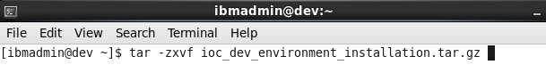

9)Installing DB2

## About this task

DB2 version 10.5 Express-C is included in the installation package.

## Procedure

1. Log on as a root user.
2. Double-click or unzip the v10.5_linuxx64_expc.tar.gz file to open it with Archive Manager, and extract the contents into a temporary installation directory. 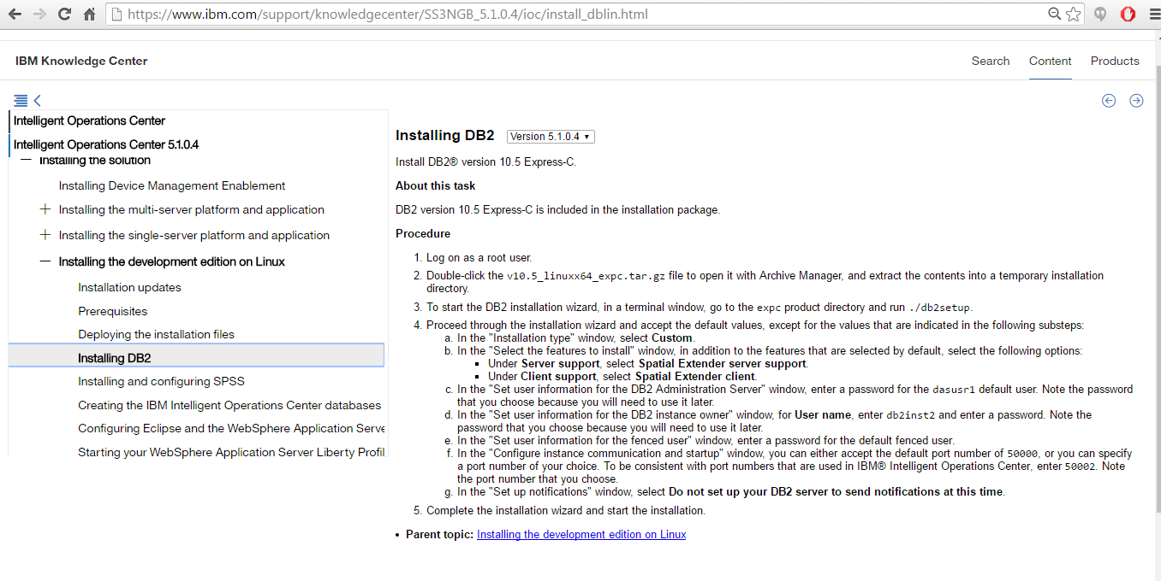
3. To start the DB2 installation wizard, in a terminal window, go to the expc product directory and run./db2setup. 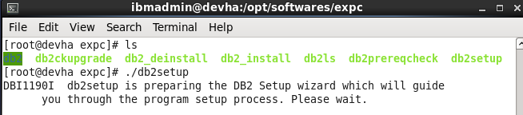 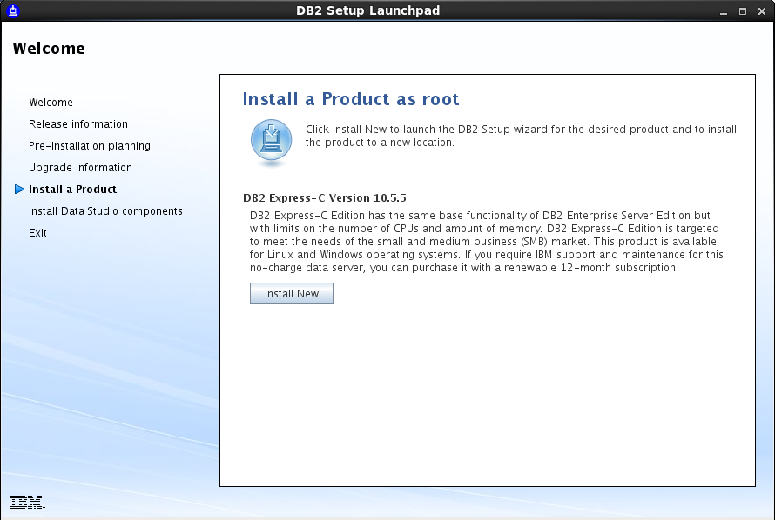 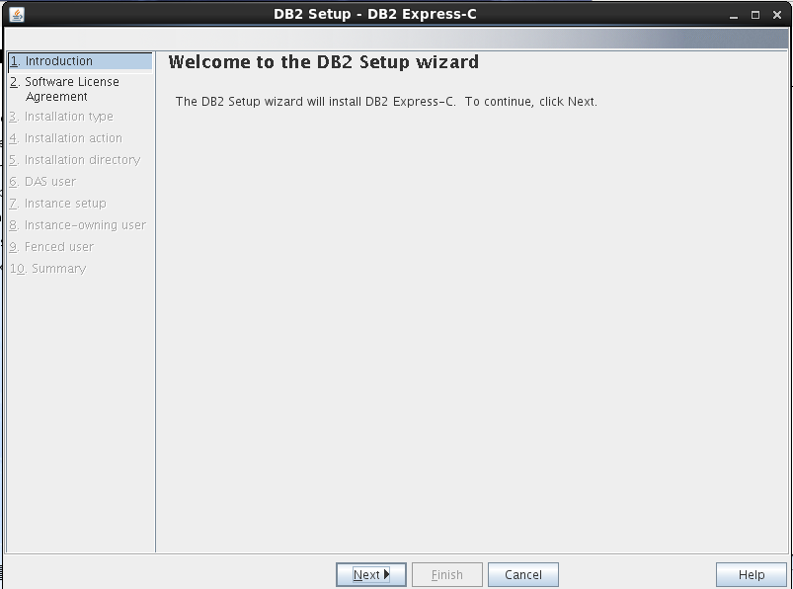 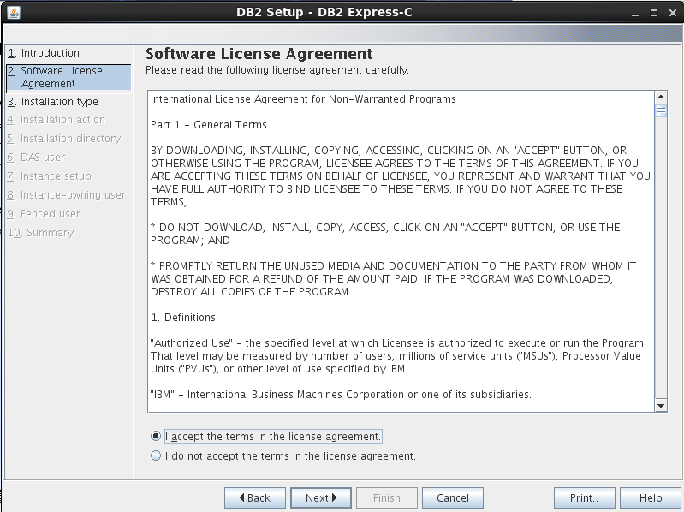
4. Proceed through the installation wizard and accept the default values, except for the values that are indicated in the following substeps:
   1. In the "Installation type" window, select**Custom**. 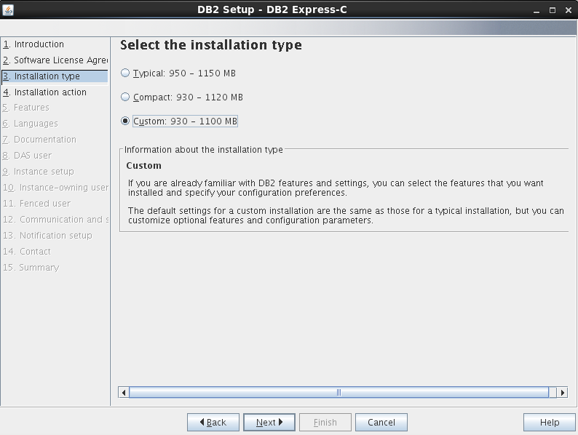 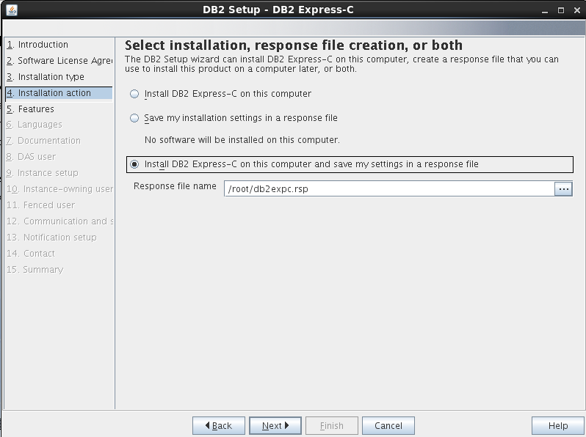
   2. In the "Select the features to install" window, in addition to the features that are selected by default, select the following options:
      * Under **Server support**, select **Spatial Extender server support**.
      * Under **Client support**, select **Spatial Extender client**. 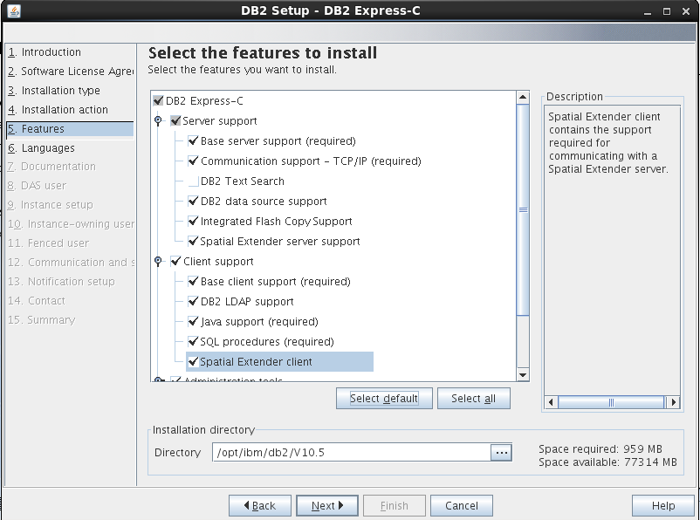
      * 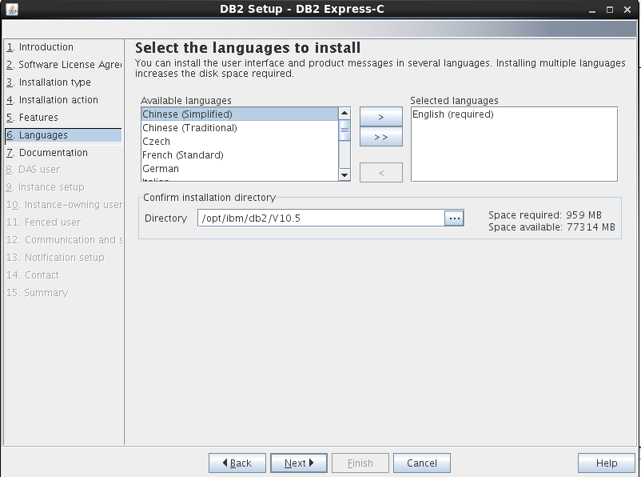 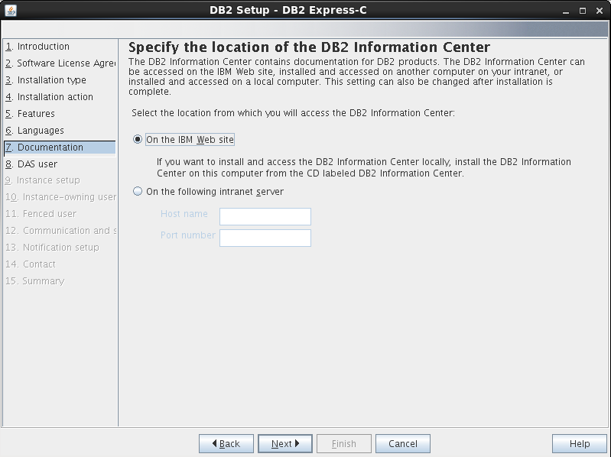
   3. In the "Set user information for the DB2 Administration Server" window, enter a password for the dasusr1 default user. Note the password that you choose because you will need to use it later. 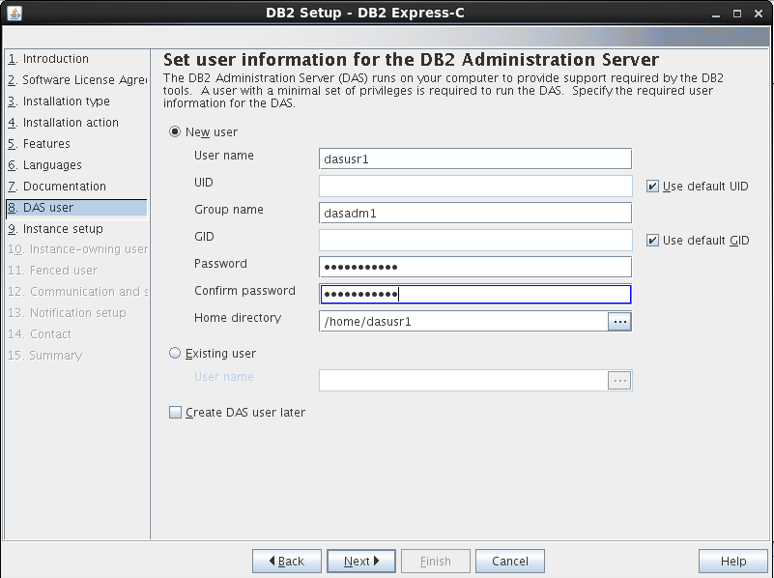
   4. In the "Set user information for the DB2 instance owner" window, for **User name**, enterdb2inst2 and enter a password. Note the password that you choose because you will need to use it later. 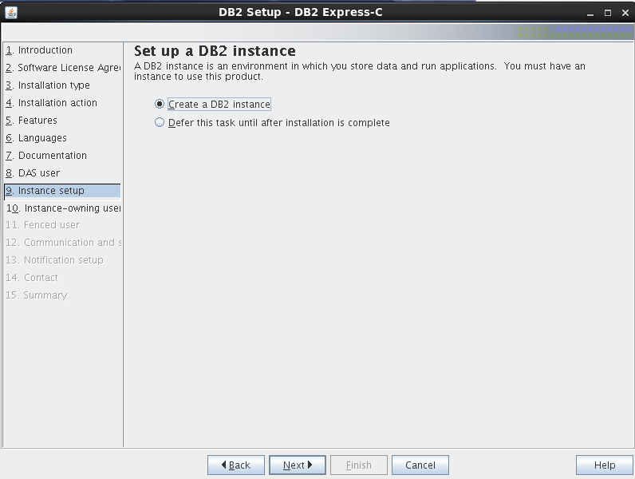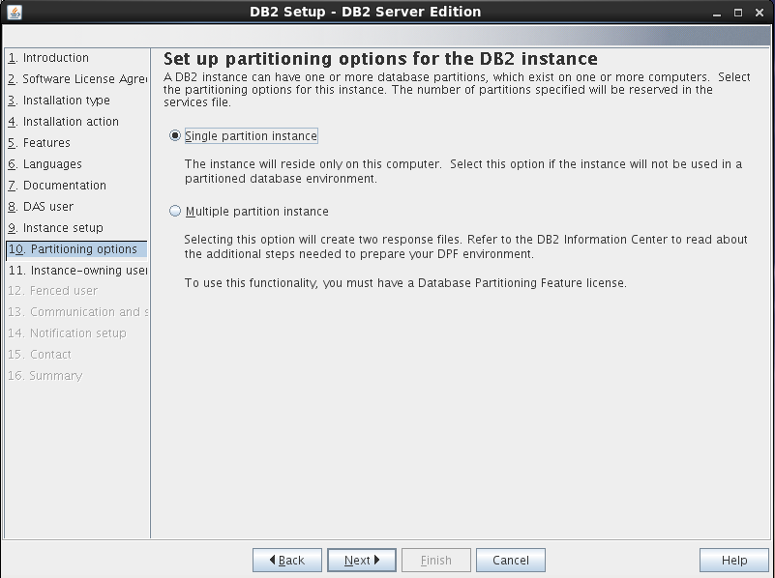 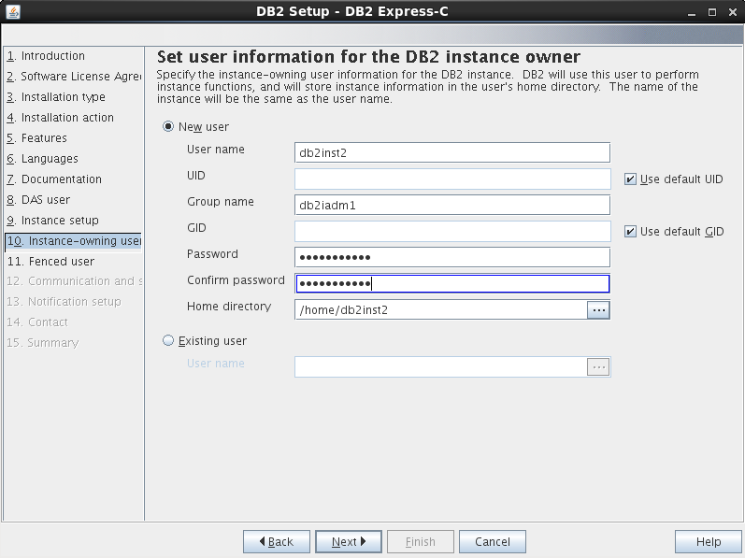
   5. In the "Set user information for the fenced user"window, enter a password for the default fenced user. 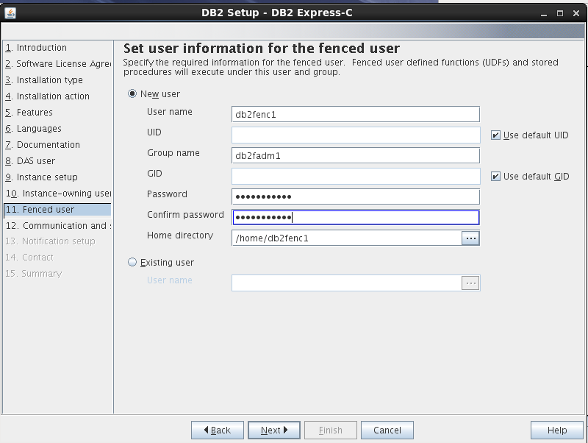
   6. In the "Configure instance communication and startup" window, you can either accept the default port number of 50000, or you can specify a port number of your choice. To be consistent with port numbers that are used inIBM Intelligent Operations Center, enter50002. Note the port number that you choose. 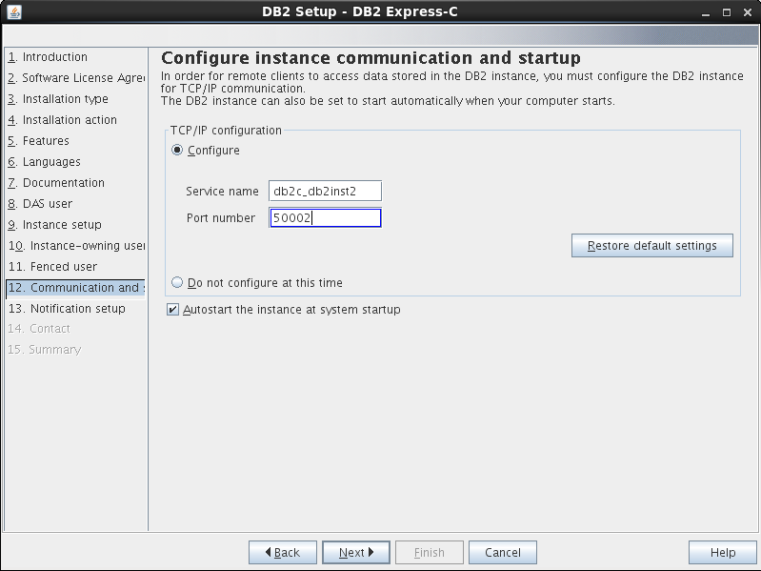 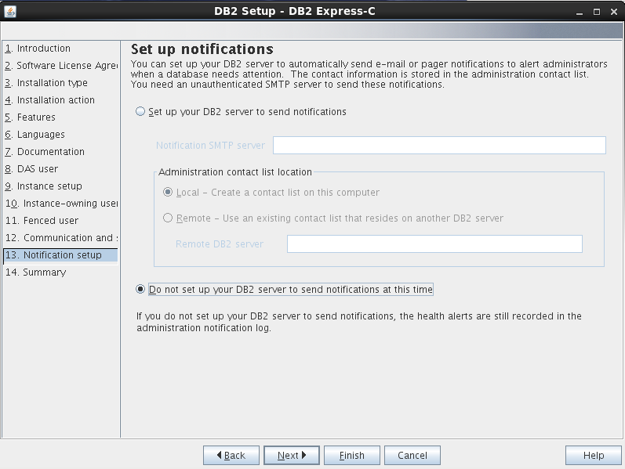
   7. In the "Set up notifications" window, select **Do not set up your DB2 server to send notifications at this time**.
5. Complete the installation wizard and start the installation.

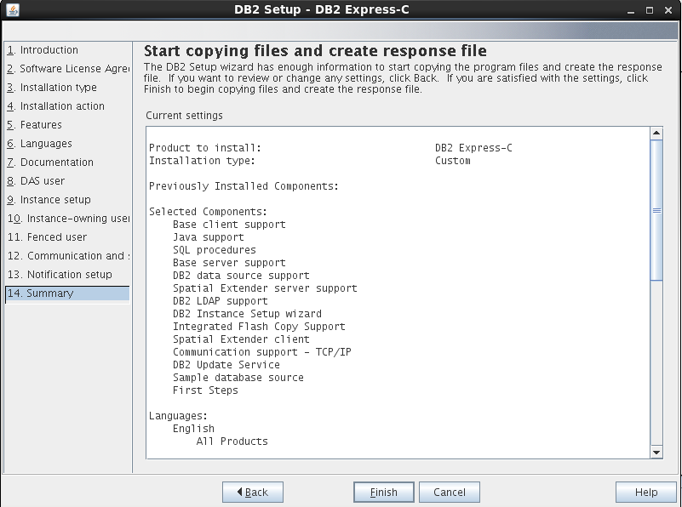

6.Click Finish to finish installation

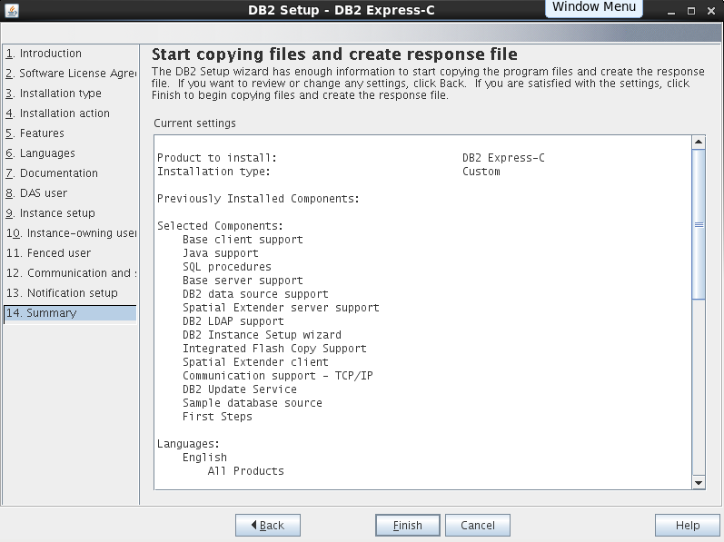 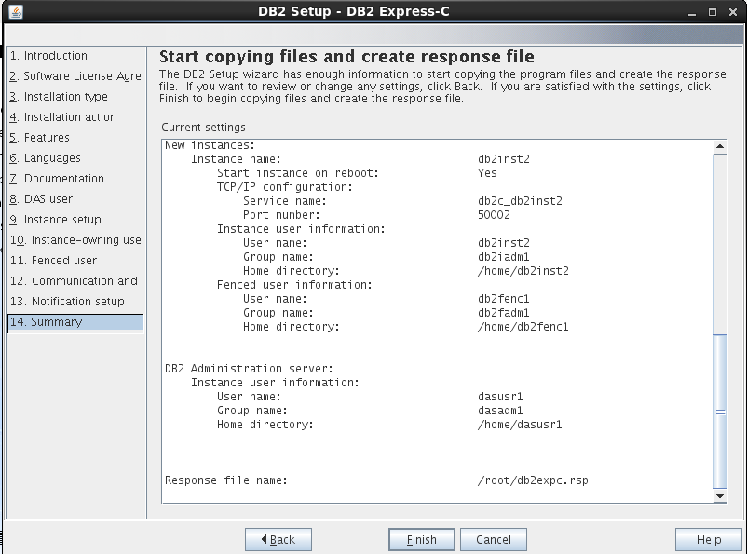 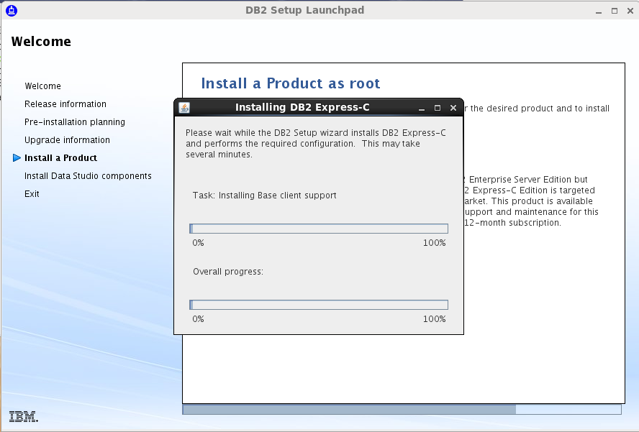 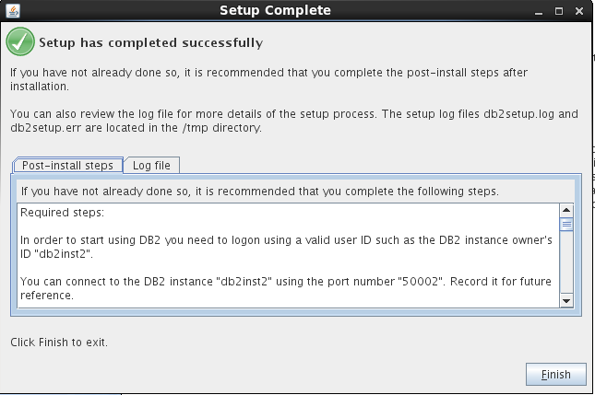

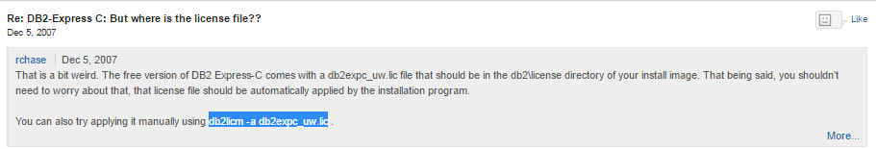 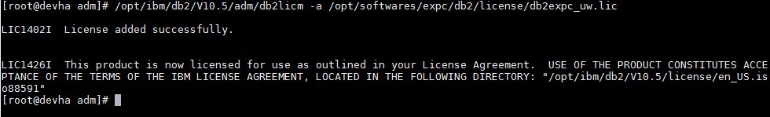

# 10)Installing and configuring SPSS

If you want to run the SPSS-based analytics, install and configure SPSS®.

## About this task

Install and extract the SPSS files in the following order:

* spss_mod_svr_17.0_lx86_ml.bin that containsSPSS Modeler Server 17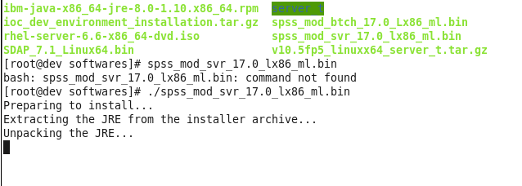
* spss_mod_btch_17.0_Lx86_ml.bin that containsSPSS Modeler Batch 17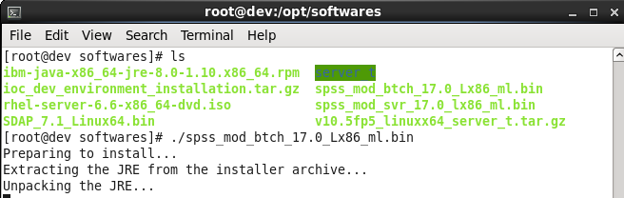
* SPSS_DATA_ACCESS_PACK_7.1.1_MP_EN.zip that contains SPSS Data Access Pack 7.1.1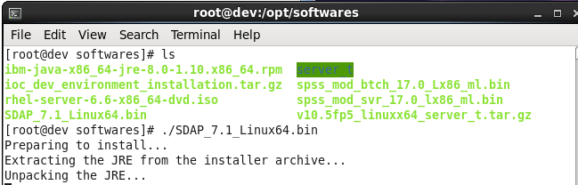

## Procedure

1. Extract and install Modeler Server. Follow the instructions in the installer.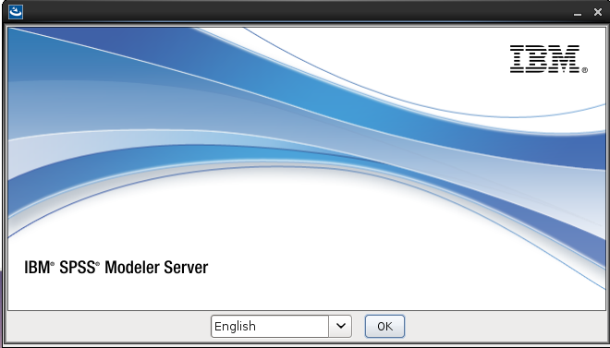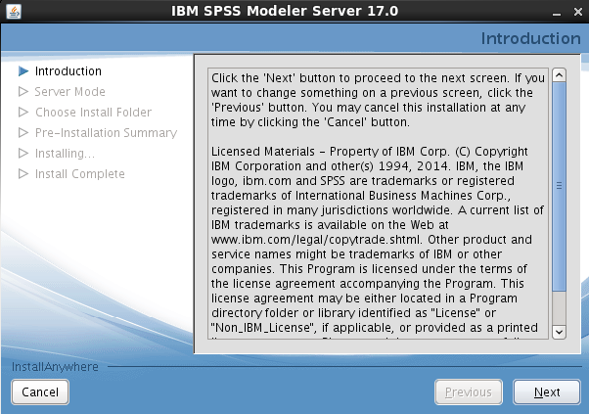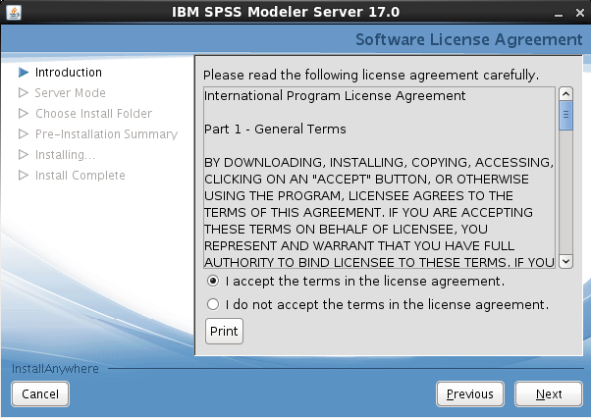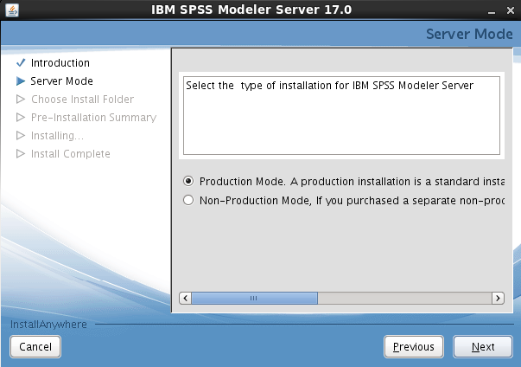

And set the installation directory to the following value:

/opt/IBM/SPSS/ModelerServer/17.0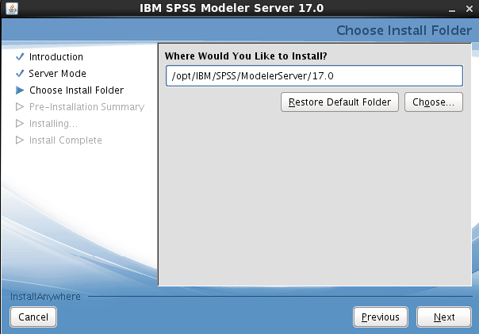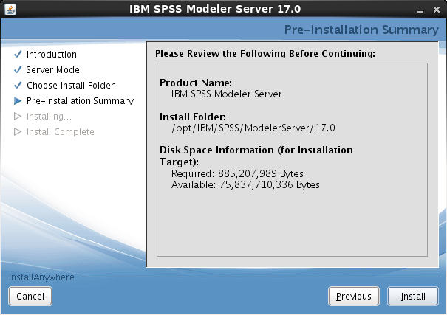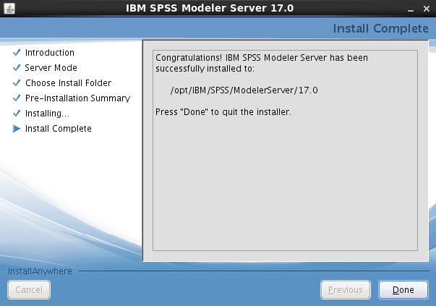

1. Extract and install Modeler Batch. Follow the instructions in the installer,

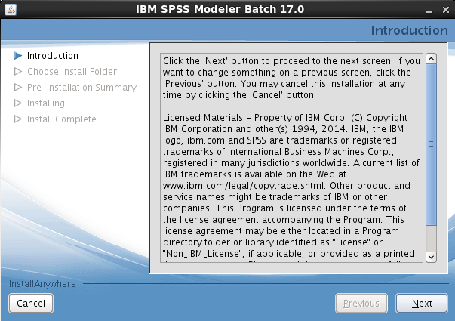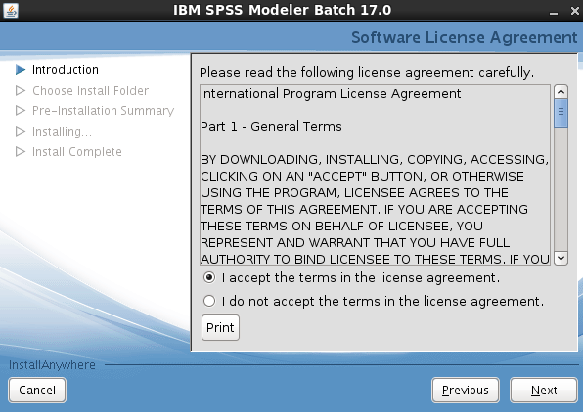

And set the installation directory to the following value:

/opt/IBM/SPSS/ModelerBatch/17.0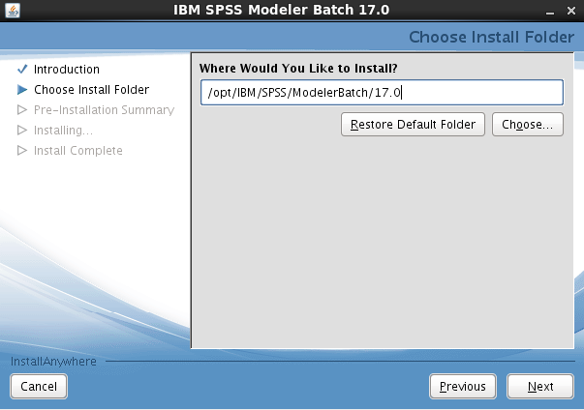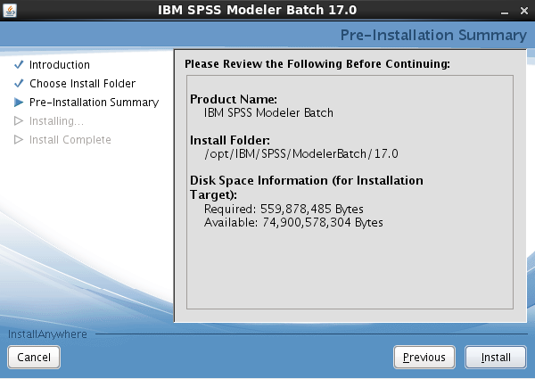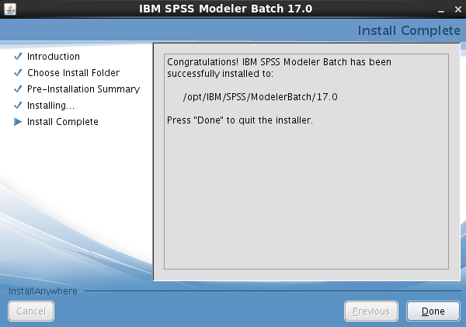

1. Install Data Access Pack. Follow the instructions in the installer, and set the installation directory to the following value:

/opt/IBM/SPSS/DataAccessPack/7.1

* 1. If a second installer is not launched automatically, navigate to the/opt/IBM/SPSS/DataAccessPack/7.1directory and run setup to complete the installation. If the second installer requests an installation directory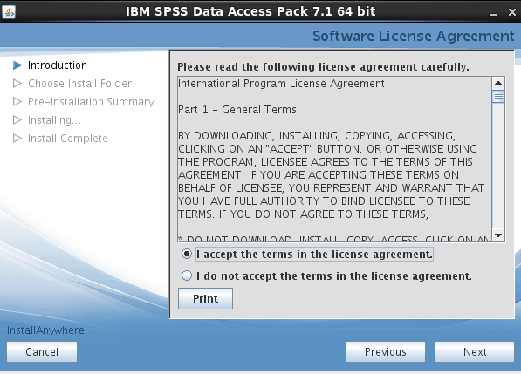Set the directory to the following value:

/opt/IBM/SPSS/DataAccessPack/7.1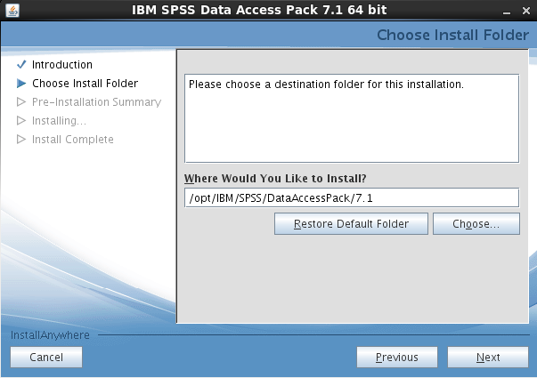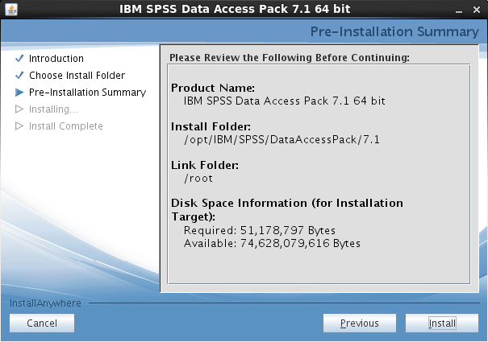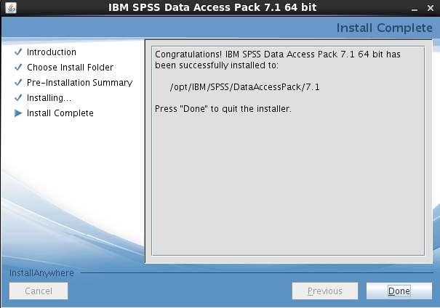

To create the SPSS ODBC data sources, complete the following steps:

1. Run the setodbcpath.sh script in the following directory:

/opt/IBM/SPSS/DataAccessPack/7.1

1. Back up the odbc.ini file in the following directory:

/opt/IBM/SPSS/DataAccessPack/7.1

1. Edit the odbc.ini file. After the textTraceDll=/opt/IBM/SPSS/DataAccessPack/7.1/lib/XEtrc27.so, enter the following content: 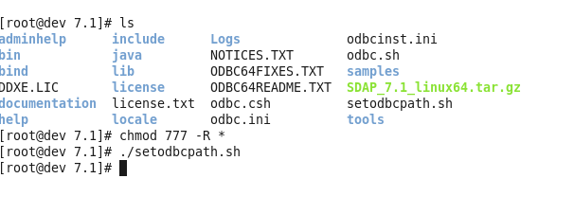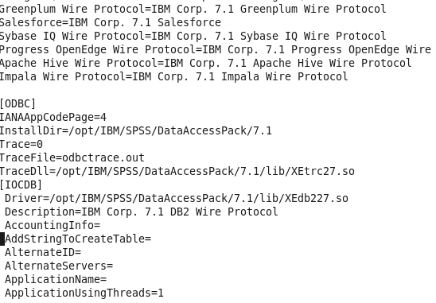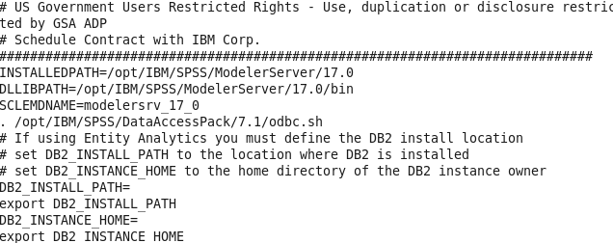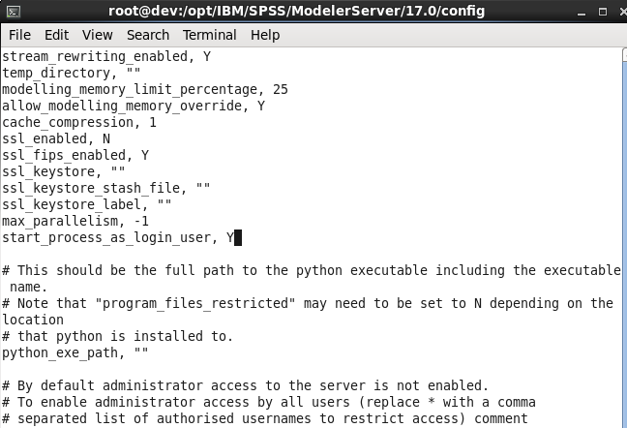
2. [IOCDB]
3. Driver=/opt/IBM/SPSS/DataAccessPack/7.1/lib/XEdb227.so
4. Description=IBM Corp. 7.1 DB2 Wire Protocol
5. AccountingInfo=
6. AddStringToCreateTable=
7. AlternateID=
8. AlternateServers=
9. ApplicationName=
10. ApplicationUsingThreads=1
11. AuthenticationMethod=0
12. BulkBinaryThreshold=32
13. BulkCharacterThreshold=-1
14. BulkLoadBatchSize=1024
15. BulkLoadFieldDelimiter=
16. BulkLoadRecordDelimiter=
17. CatalogSchema=
18. CharsetFor65535=0
19. ClientHostName=
20. ClientUser=
21. #Collection applies to z/OS and iSeries only
22. Collection=
23. ConcurrentAccessResolution=0
24. ConnectionReset=0
25. ConnectionRetryCount=0
26. ConnectionRetryDelay=3
27. CurrentFuncPath=
28. #Database applies to DB2 UDB only
29. Database=IOCDB
30. DefaultIsolationLevel=1
31. DynamicSections=1000
32. EnableBulkLoad=0
33. EncryptionMethod=0
34. FailoverGranularity=0
35. FailoverMode=0
36. FailoverPreconnect=0
37. GrantAuthid=PUBLIC
38. GrantExecute=1
39. GSSClient=native
40. HostNameInCertificate=
41. IpAddress=localhost
42. KeyPassword=
43. KeyStore=
44. KeyStorePassword=
45. LoadBalanceTimeout=0
46. LoadBalancing=0
47. #Location applies to z/OS and iSeries only
48. Location=
49. LogonID=
50. MaxPoolSize=100
51. MinPoolSize=0
52. Password=
53. PackageCollection=NULLID
54. PackageNamePrefix=DD
55. PackageOwner=
56. Pooling=0
57. ProgramID=
58. QueryTimeout=0
59. ReportCodePageConversionErrors=0
60. TcpPort=50002
61. TrustStore=
62. TrustStorePassword=
63. UseCurrentSchema=0
64. ValidateServerCertificate=1
65. WithHold=1
66. XMLDescribeType=-10
67. [IOCDATA]
68. Driver=/opt/IBM/SPSS/DataAccessPack/7.1/lib/XEdb227.so
69. Description=IBM Corp. 7.1 DB2 Wire Protocol
70. AccountingInfo=
71. AddStringToCreateTable=
72. AlternateID=
73. AlternateServers=
74. ApplicationName=
75. ApplicationUsingThreads=1
76. AuthenticationMethod=0
77. BulkBinaryThreshold=32
78. BulkCharacterThreshold=-1
79. BulkLoadBatchSize=1024
80. BulkLoadFieldDelimiter=
81. BulkLoadRecordDelimiter=
82. CatalogSchema=
83. CharsetFor65535=0
84. ClientHostName=
85. ClientUser=
86. #Collection applies to z/OS and iSeries only
87. Collection=
88. ConcurrentAccessResolution=0
89. ConnectionReset=0
90. ConnectionRetryCount=0
91. ConnectionRetryDelay=3
92. CurrentFuncPath=
93. #Database applies to DB2 UDB only
94. Database=IOCDATA
95. DefaultIsolationLevel=1
96. DynamicSections=1000
97. EnableBulkLoad=0
98. EncryptionMethod=0
99. FailoverGranularity=0
100. FailoverMode=0
101. FailoverPreconnect=0
102. GrantAuthid=PUBLIC
103. GrantExecute=1
104. GSSClient=native
105. HostNameInCertificate=
106. IpAddress=localhost
107. KeyPassword=
108. KeyStore=
109. KeyStorePassword=
110. LoadBalanceTimeout=0
111. LoadBalancing=0
112. #Location applies to z/OS and iSeries only
113. Location=
114. LogonID=
115. MaxPoolSize=100
116. MinPoolSize=0
117. Password=
118. PackageCollection=NULLID
119. PackageNamePrefix=DD
120. PackageOwner=
121. Pooling=0
122. ProgramID=
123. QueryTimeout=0
124. ReportCodePageConversionErrors=0
125. TcpPort=50002
126. TrustStore=
127. TrustStorePassword=
128. UseCurrentSchema=0
129. ValidateServerCertificate=1
130. WithHold=1

XMLDescribeType=-10

1. Copy the odbc.ini file to the following directory:

/opt/IBM/SPSS/DataAccessPack/7.1

**Note:** This file defines two new ODBC data sources,IOCDB and IOCDATA, on localhost. If the databases are hosted on different servers, update the IP address and TCP port properties for each data source to point to the appropriate server.

1. In the /opt/IBM/SPSS/ModelerServer/17.0/bindirectory, enter the following commands:
2. rm -f libspssodbc.so

ln -s libspssodbc_datadirect.so libspssodbc.so

1. Edit the modelersrv.sh file in the following directory:

/opt/IBM/SPSS/ModelerServer/17.0

* 1. Add the following line to the file after the lineSCLEMDNAME=modelersrv_17_0:

. /opt/IBM/SPSS/DataAccessPack/7.1/odbc.sh

1. Edit the options.cfg in the following directory:

/opt/IBM/SPSS/ModelerServer/17.0/config

* 1. Set the value of**start_process_as_login_user** to **Y**.
  2. If the model server is already started, stop and restart the server by running the following commands as the ibmadmin user from/opt/IBM/SPSS/ModelerServer/17.0
  3. ./modelersrv.sh stop
  4. ./modelersrv.sh start

./modelersrv.sh list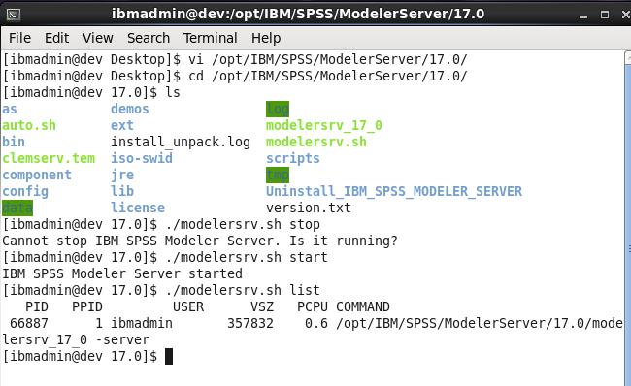

**Note:** Ensure that the ASKSPSSEnabledsystem property is set to true. Also, ensure that the ID and password credentials in theASKCredentials system property are correct for your solution.

# 11) Creating the IBM Intelligent Operations Center databases

## Procedure

Create the IOCDB database

1. Open a terminal window and enter the following command as the ibmadmin user:

chmod 755 /home/ibmadmin

1. Switch users to the DB2 instance user.
2. Go to the/home/ibmadmin/workspaces/spf/dev_ioc_install/ioc/config/dbdirectory, which is where the database shell scripts are located.
3. Enter the following command: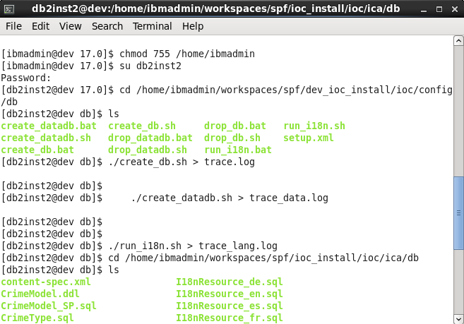

./create_db.sh > trace.log

Create the IOCDATA database

1. Enter the following command:

./create_datadb.sh > trace_data.log

Add the language translations to the database

1. Enter the following command:

./run_i18n.sh > trace_lang.log

If you want to use Integrated Crime Analytics, configure the database for Integrated Crime Analytics:

1. Go to the/home/ibmadmin/workspaces/spf/ioc_install/ioc/ica/dbdirectory, which is where the database shell scripts are located.
2. Enter the following command:

./updateIOCDB_db2.sh > traceica.log

# 12) Configuring Eclipse and the WebSphere Application Server Liberty Profile server

## Procedure

1. Log on as the ibmadmin user.
2. To start Eclipse, in a terminal window, enter the following command:

/home/ibmadmin/eclipse/eclipse

Note:If u get the error of JDK you need to set the Java Path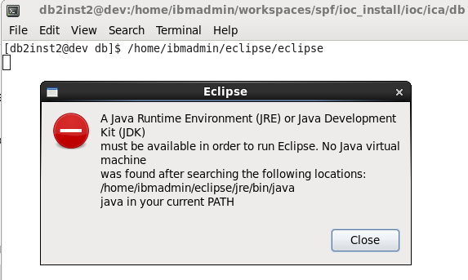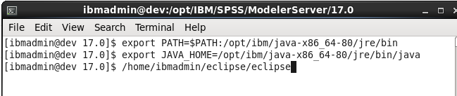

1. At the prompt, select the following workspace:/home/ibmadmin/workspaces/spf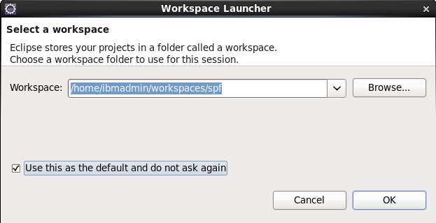
2. Configure the server:
   1. In Eclipse, in the Servers view, right-click in any open space and then click **New** > **Server**.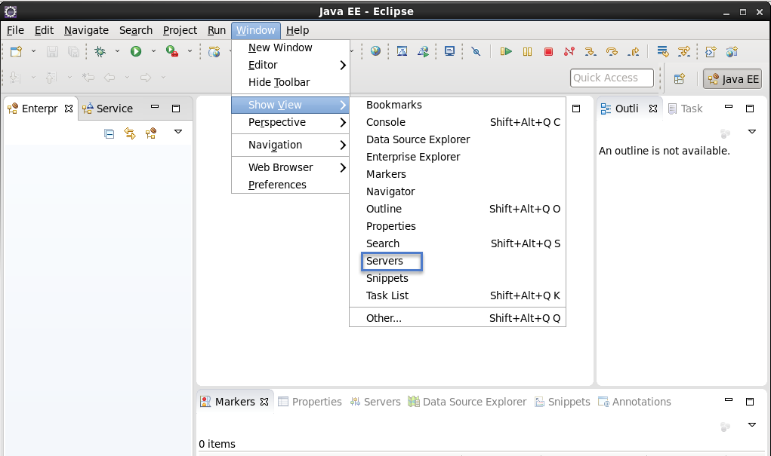
   2. Either enter or select the following values, and then click **Next**:
      * For **Server type**, select **IBM** > **WebSphere Application Server Liberty Profile**.
      * For **Server's host name**, enter localhost.
      * For **Server name**, enter WebSphere Application Server Liberty Profile at localhost. 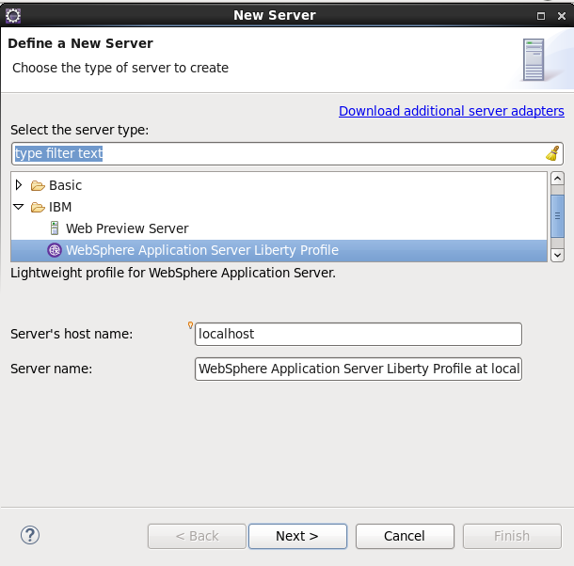
   3. Either enter or select the following values, and then click **Next**:
      * For **How do you want to create the runtime environment**, select **Choose an existing installation**.
      * For **Path**, enter /home/ibmadmin/liberty.
      * For **JRE**, select **Use default JRE**. 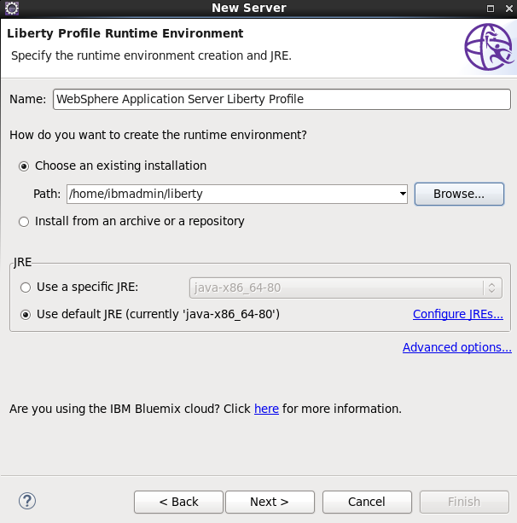
   4. For **Liberty profile server**, select **defaultServer**, and then click **Finish**.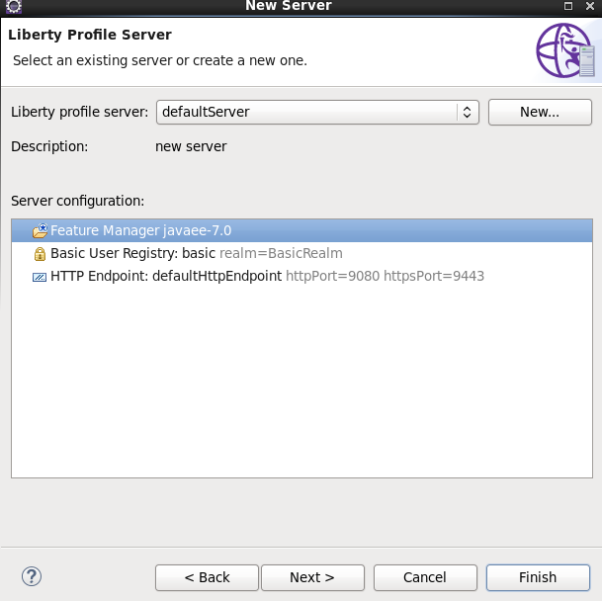
3. Import the IBM Intelligent Operations Center V5.1development environment projects into the workspace:
   1. In Eclipse, click **File** > **Import** > **General** > **Existing Projects into Workspace**, and then click **Next**.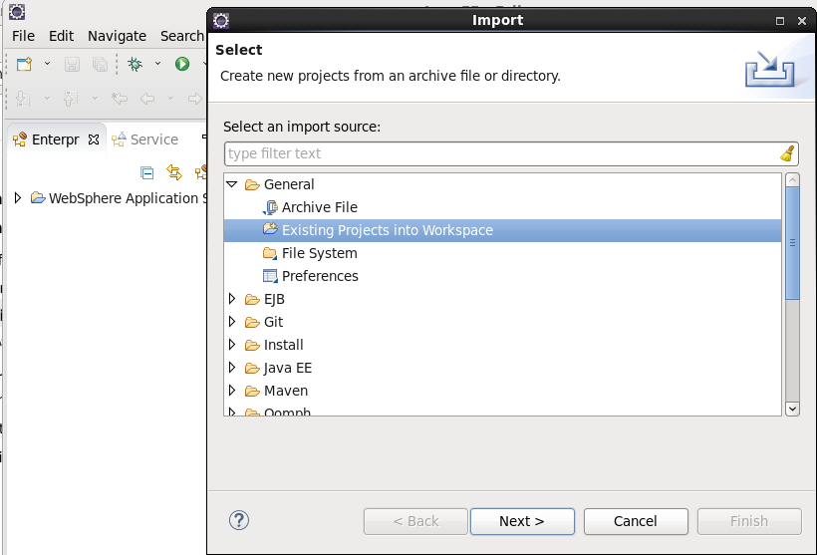
   2. Select **Select root directory**.
   3. Click **Browse**, and select/home/ibmadmin/workspaces/spf. The Projects list shows the available projects.
   4. Click **Select All**.
   5. Under Options and Working Sets, clear all the options.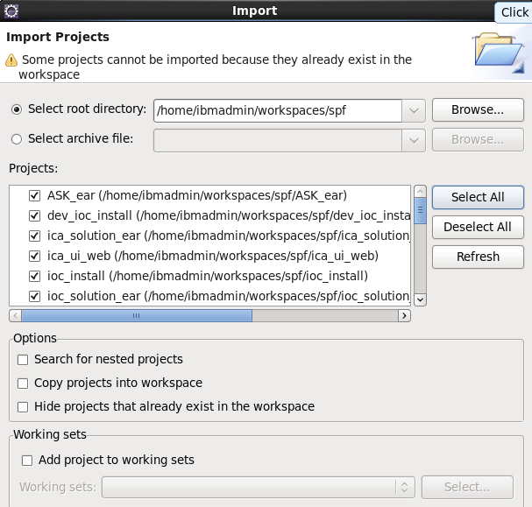
   6. Click **Finish**.
4. Wait for Eclipse to refresh and build the workspace. This process can take up to 5 minutes.
5. Add the projects to the server:
   1. In Eclipse, in the Servers view, right-click**WebSphere Application Server Liberty Profile** >**Add and Remove**.
   2. Add the following projects to the server:
      * ica_solution_ear
      * ioc_solution_ear
      * ioc_theme_ear
   3. Optional: If you installed SPSS® Modeler Server 17, SPSS Modeler Batch 17, and SPSS Data Access Pack 7.1.1, add the ASK_ear project to the server. 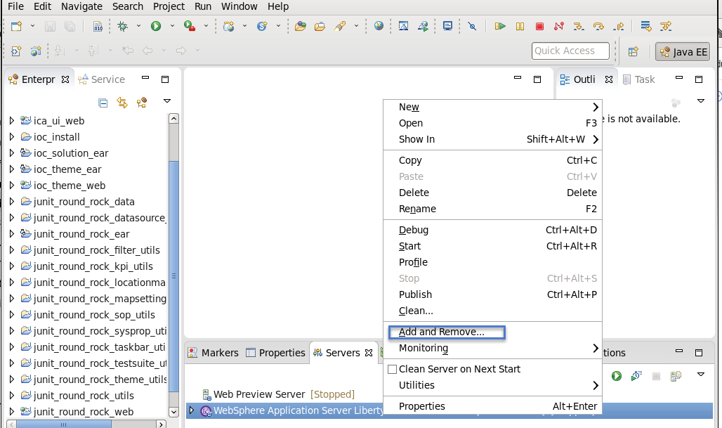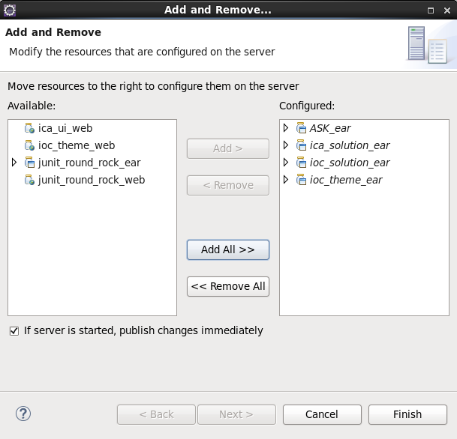
6. From Eclipse, edit the/home/ibmadmin/workspaces/spf/dev_ioc_install/ioc/config/liberty/setup.shscript and modify all the variables to match your environment. Ensure that you update theDB2_HOSTNAME, DB2_PORT, DB2_INSTANCE_USER, and JAVA_DIR variables to match the values that you selected when you installed DB2.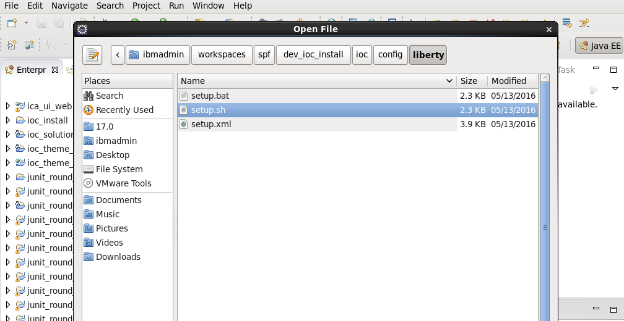
7. db2_hostname=localhost
8. db2_port=50002
9. db2_instance_user=db2inst2
10. SET DB2_INSTANCE_USER_PWD=db2_instance_user_pwd

java_dir=/opt/ibm/java-x86_64-70/jre/bin

* 1. The java_dir variable in the setup.sh script refers to a Java 7.0 installation location. If the installation uses Java 8.0, update the variable to refer to the Java 8.0 path:

java_dir=/opt/ibm/java-x86_64-80/jre/bin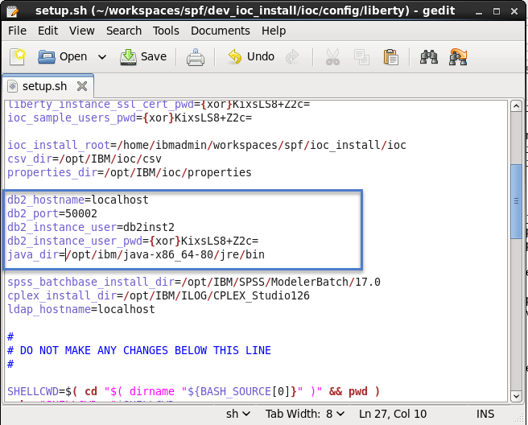

1. To run the setup.sh script, enter the following commands as the ibmadmin user, and ensure that the script has finished running before you proceed to the next step:
2. cd /home/ibmadmin/workspaces/spf/dev_ioc_install/ioc/config/liberty

./setup.sh 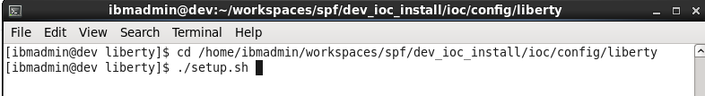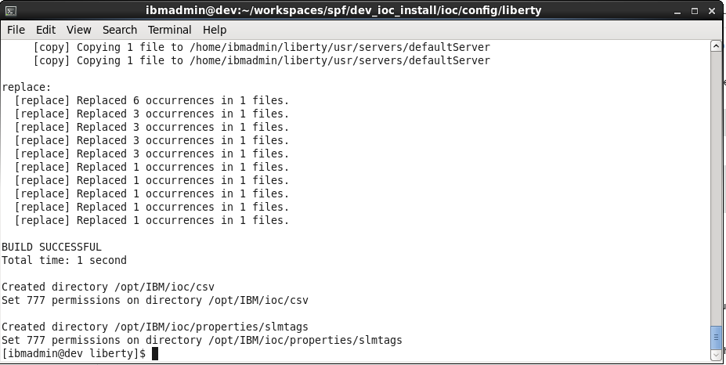

1. Optional: If you added the ASK_ear project to the server, to configure ASK, enter the following commands as a root user:
2. mkdir -p /opt/IBM/ioc/ASK
3. cp -r /home/ibmadmin/workspaces/spf/ioc_install/ioc/ASK /opt/IBM/ioc
4. chown ibmadmin:ibmadmin /opt/IBM/ioc/ASK/*

chmod -R 777 /opt/IBM/ioc/ASK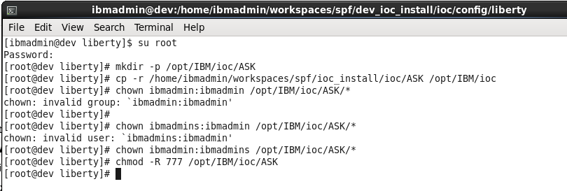

1. On the **Servers** tab in the bottom pane, expand**WebSphere Application Server Liberty Profile at localhost**.
2. To open the server.xml file, double-click **Server Configuration [server.xml]**.
3. Click the **Design** tab. The **Design** tab is at the bottom of the **Server Configuration: defaultServer (server.xml)**tab.

**Note:** Do not edit the XML on the **Source** tab.

1. On the **Design** tab, expand **Server Configuration** > **Data Source: jdbc/ioc**, and then click **DB2 JCC Properties**. Scroll down through the list of properties to locate and update the following value with the value that you configured for your databases:
   1. **Password**

Next to the **Password** field, click **Set**. In the "Set Password" window, enter the password and accept the default encoding method.

**Note:** Set the **Password** value and then confirm that the **Port number**, **Server name**, and **User**values are already set correctly. 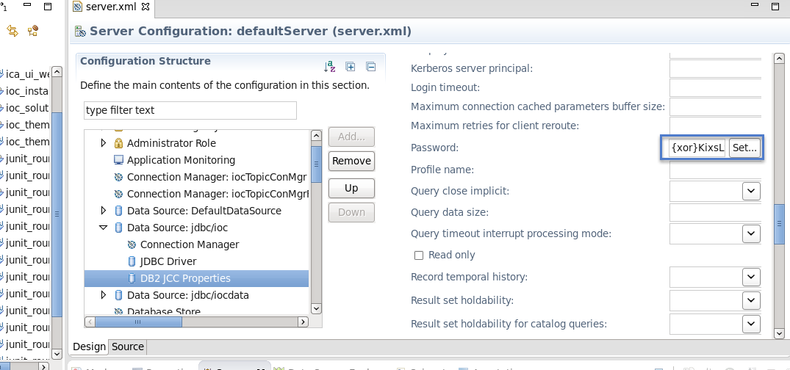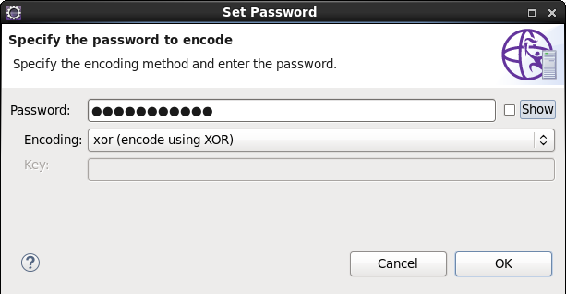

1. On the **Design** tab, expand **Server Configuration** > **Data Source: jdbc/iocdata**, and then click **DB2 JCC Properties**. Scroll down through the list of properties to locate and update the following value with the value that you configured for your databases:
   1. **Password**

Next to the **Password** field, click **Set**. In the "Set Password" window, enter the password and accept the default encoding method.

**Note:** Set the **Password** value and then confirm that the **Port number**, **Server name**, and **User**values are already set correctly. 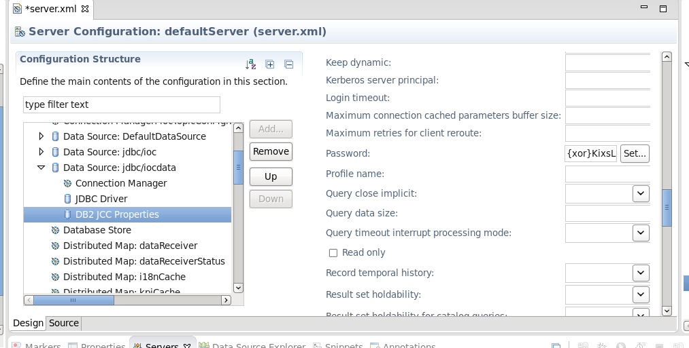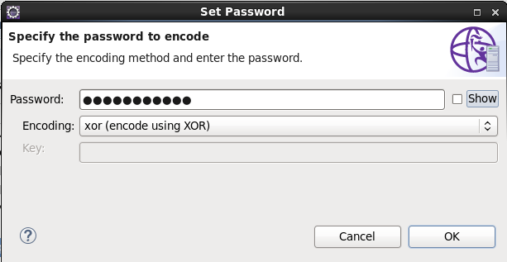

1. On the **Design** tab, expand **Server Configuration** > **Data Source: DefaultDataSource**, and then click **DB2 JCC Properties**. Scroll down through the list of properties to locate and update the following values with the value that you configured for your databases:
   1. **Password**

Next to the **Password** field, click **Set**. In the "Set Password" window, enter the password and accept the default encoding method.

**Note:** Set the **Password** value and then confirm that the **Port number**, **Server name**, and **User**values are already set correctly. 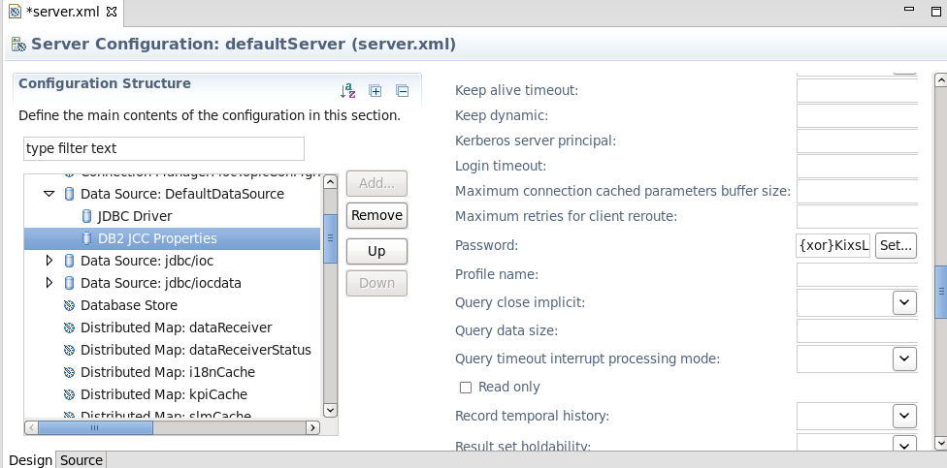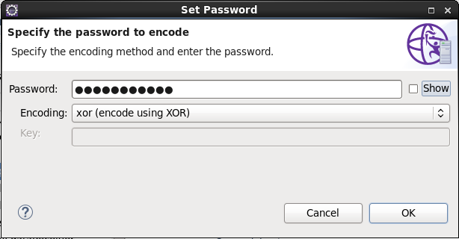

1. To save the server configuration, press CTRL-S. Alternatively, close the **Server Configuration: defaultServer (server.xml)** tab and save the server configuration at the prompt.

**Note:** It might take several minutes for the configuration to be saved, during which time Eclipse appears to stop responding.

1. Create the SSL certificate:
   1. In Eclipse, in the Servers view, right-click**WebSphere Application Server Liberty Profile at localhost** > **Utilities** > **Create SSL Certificate.**.
   2. Either enter or select only the following values:
      * For **Keystore password**, enter a password that you will remember.
      * For **Encoding**, select **xor (encode using XOR)**.
   3. Do not select any other options, and click **Finish**.
   4. At the prompt, select **Yes** to overwrite the key.jksfile.
   5. Click **OK** to close the completion message.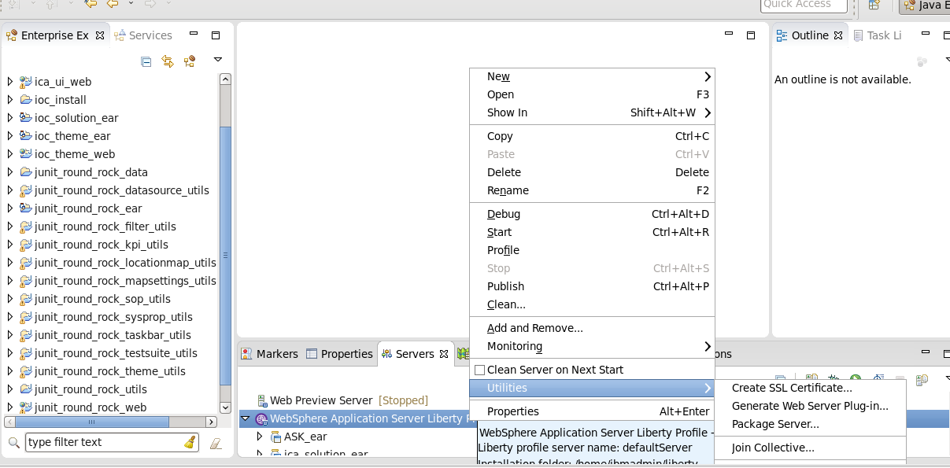

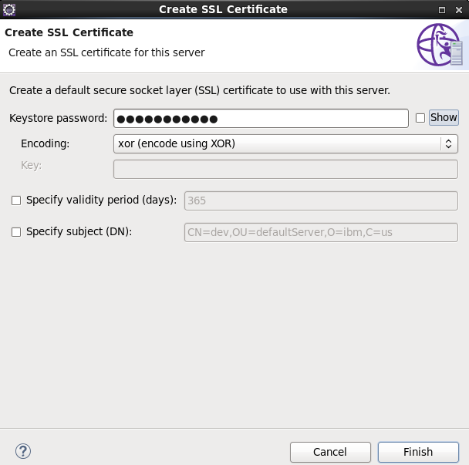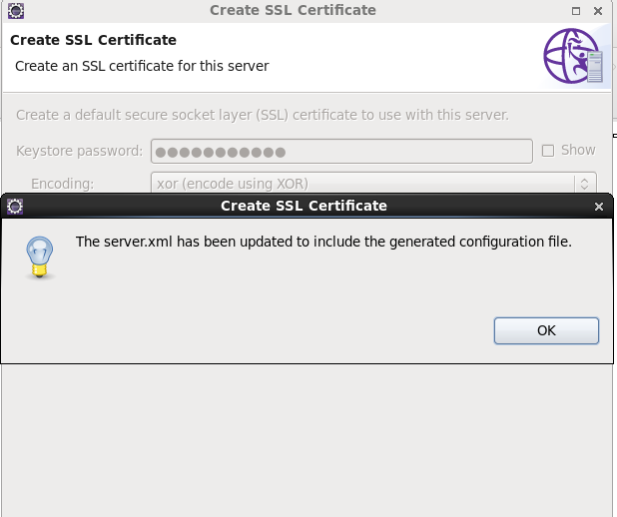

# 13) Starting your WebSphere Application Server Liberty Profile server and opening IBM Intelligent Operations Center

# Note:Set jre path

## Procedure

1. To start the WebSphere Application Server Liberty Profileserver, choose one of the following options:
   * In Eclipse, on the **Servers** tab in the bottom pane, right-click **WebSphere Application Server Liberty Profile at localhost** > **Start**.
   * Alternatively, in a terminal window, enter the following command:

/home/ibmadmin/liberty/bin/server start defaultServer

1. Review the console for messages and errors.
2. Open a browser at the following location:https://localhost:9443/ioc
3. Log on to IBM Intelligent Operations Center V5.1 with the user name sysadmin and the password us3rpa88. 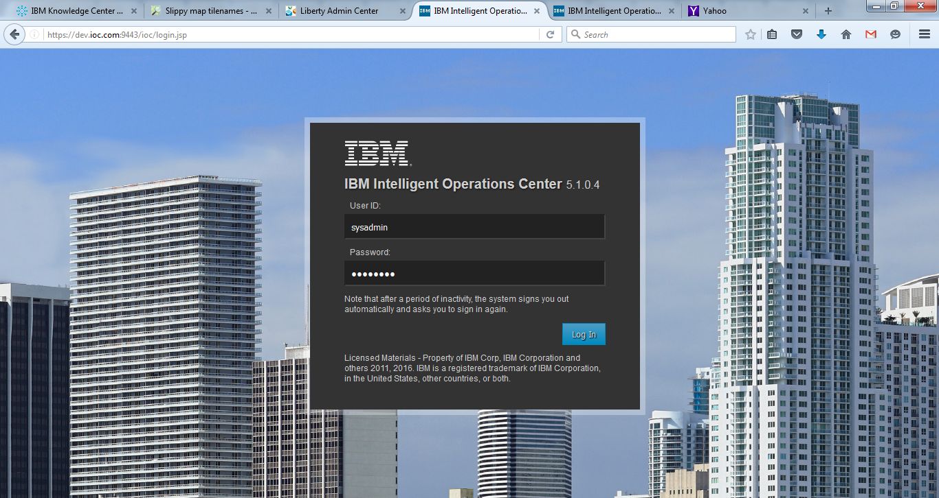

**Note:** If the Log In window displays the text null instead of prompts for your user ID and password, the cause is an issue with the database connection that you configured during the installation. Resolve the database connection issue before you attempt to log on again.

After you log on, the IBM Intelligent Operations CenterV5.1 user interface is displayed. If a map is not configured, a corresponding message is displayed.

# 

# IHS

## Procedure

1. Install IBM HTTP Server and Web Server Plugins.
   1. On the Host1 machine. log on with the "root" user ID and run IBM Installation Manager to install the IBM HTTP server and Web Server Plugins. This documentation assumes that the applications are installed in the following places:

**IBM HTTP Server home**

/opt/HTTPServer

**Web Server Plugins home**

/opt/Plugins

1. Start the Liberty profile servers to test whether you can access the MobileFirst Operations Console on Host2 and Host3 by browsing to the associated URLs:
   1. http://Host2:9080/worklight/console
   2. http://Host3:9080/worklight/console

Check that both MobileFirst Operations Console are running.

1. Run the following command on Host1 to start the IBM HTTP server.

/opt/HTTPServer/bin/httpd -d /opt/HTTPServer -k start –f /opt/HTTPServer/conf/httpd.conf

If you encounter problems during IBM HTTP server startup, see [Troubleshooting IBM HTTP Server startup](https://www.ibm.com/support/knowledgecenter/en/SSHSCD_6.3.0/com.ibm.worklight.installconfig.doc/admin/t_troubleshooting_ihs_startup.html?view=kc).

1. Ensure that the IBM HTTP Server can be accessed at the following URL in a web browser:

http://<hostname>:<port>

**Note:** 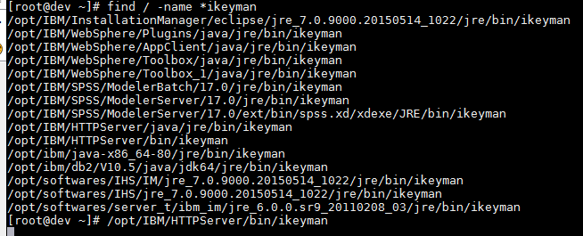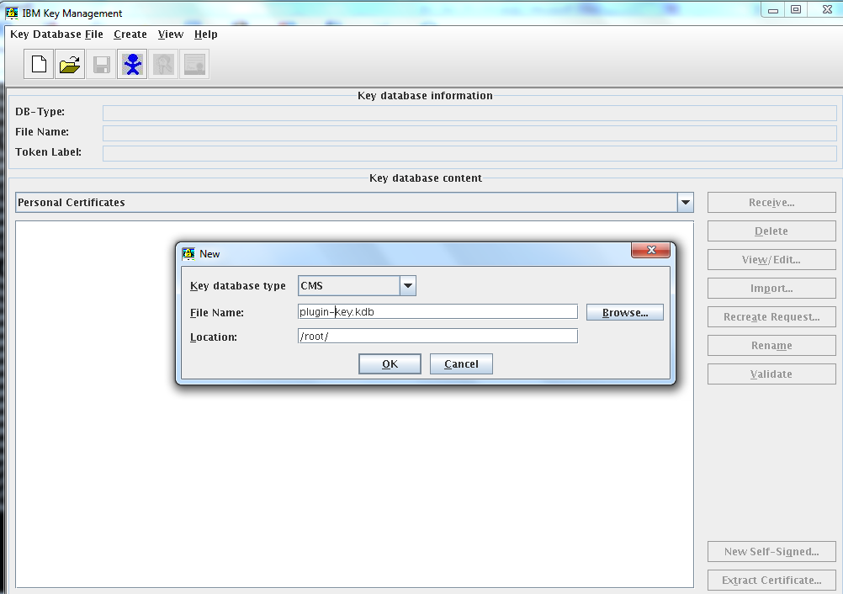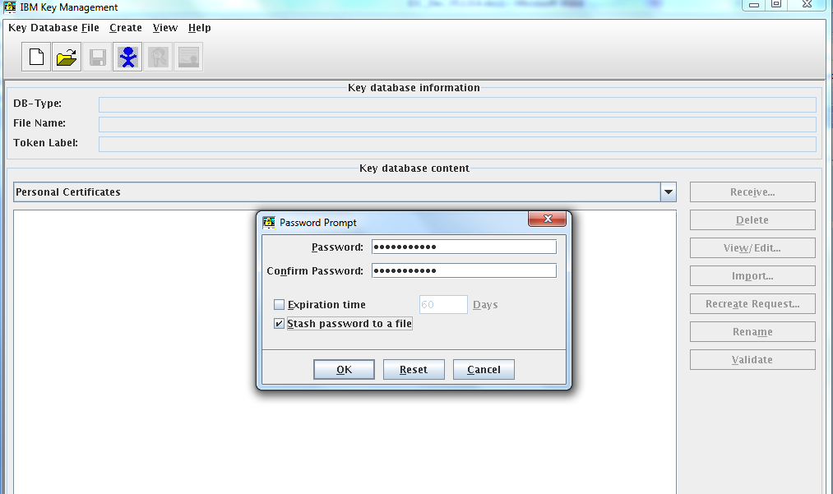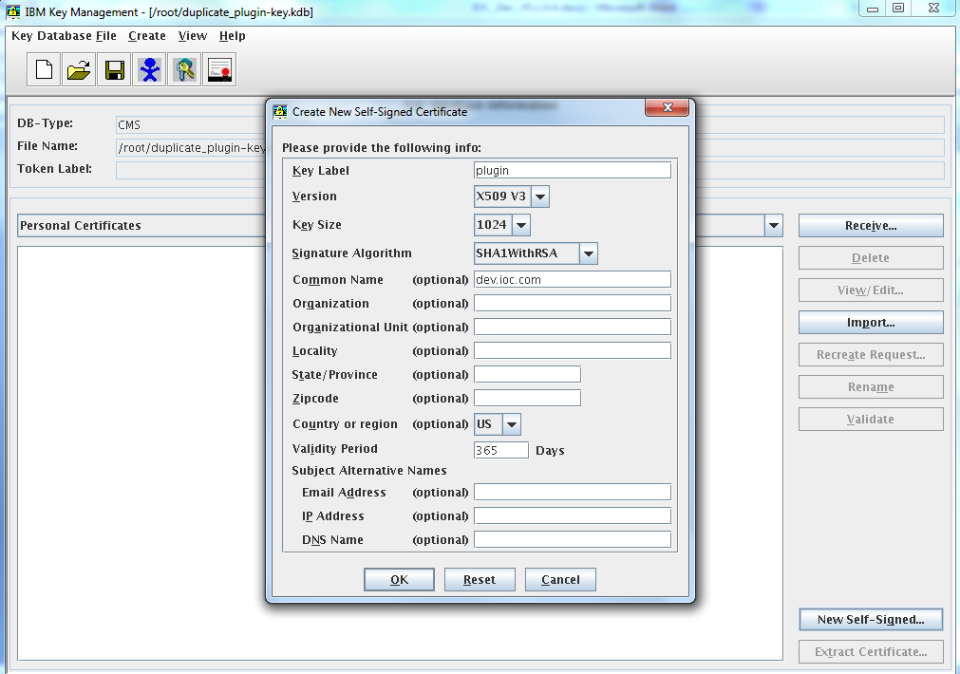

**Convert .kdb and .sth files for SSL communication**

/IBM/WebSphere/Liberty/usr/servers/lserver1/resources/security/key.jks

/home/ibmadmin/liberty/usr/servers/defaultServer/resources/security/key.jks

gskcmd -keydb -convert -pw Welcome@123 -db /home/ibmadmin/liberty/usr/servers/defaultServer/resources/security/key.jks -old_format jks -target /root/key.kdb -new_format cms -stash

gskcmd -cert -setdefault -pw Welcome@123 -db /root/plugin-key.kdb -label default

/IBM/WebSphere/Plugins/config/webserver1/

<Property Name="keyring" Value="/root/plugin-key.kdb"/>

<Property Name="stashfile" Value="/root/plugin-key.sth"/>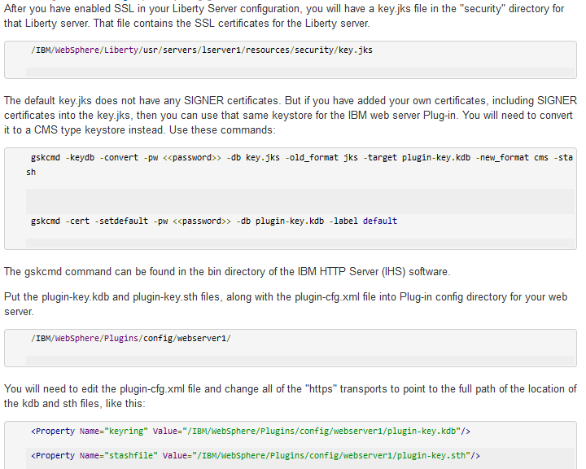

1. For each Liberty server, generate a web server plug-in configuration file named plugin-cfg.xml. The web server plug-in is used to forward HTTP requests from the web server to the application server.

Method (a):

* 1. Start the server that hosts your applications and ensure that the localConnector-1.0 feature and other required features are included in the server configuration. Use the pluginConfiguration element in the server configuration file to specify the **webserverPort** and **webserverSecurePort** attributes for requests that are forwarded from the web server. By default, the value of **webserverPort** is 80 and the value of**webserverSecurePort** is 443. Assign the value * to the host attribute to ensure that applications on the Liberty server can be accessed from a remote browser. Here is an example of a server.xml server configuration file:
  2. <server description="new server">
  3. <featureManager>
  4. <feature>localConnector-1.0</feature>
  5. <feature>jsp-2.2</feature>
  6. </featureManager>
  7. <httpEndpoint id="defaultHttpEndpoint" host="*" httpPort="9080">
  8. <tcpOptions soReuseAddr="true" />
  9. </httpEndpoint>
  10. <pluginConfiguration webserverPort="80" webserverSecurePort="443"/>

</server>

Method (b):

Use one of the following methods to generate the plugin-cfg.xml file for the Liberty server running your application.

* + - jConsole:
      1. Using the same JDK as the server, run the jConsole Java™ utility from a command prompt. For example, run the following command:

C:\java\b**in**\jconsole

* + - 1. In the jConsole window, click **Local Process**, click the server process in the list of local processes, and then click **Connect**.

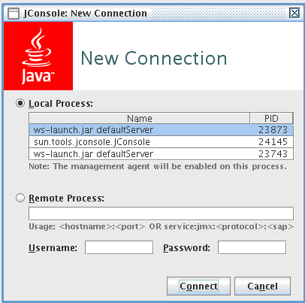

* + - 1. In the Java Monitoring & Management Console, click the **MBeans** tab.

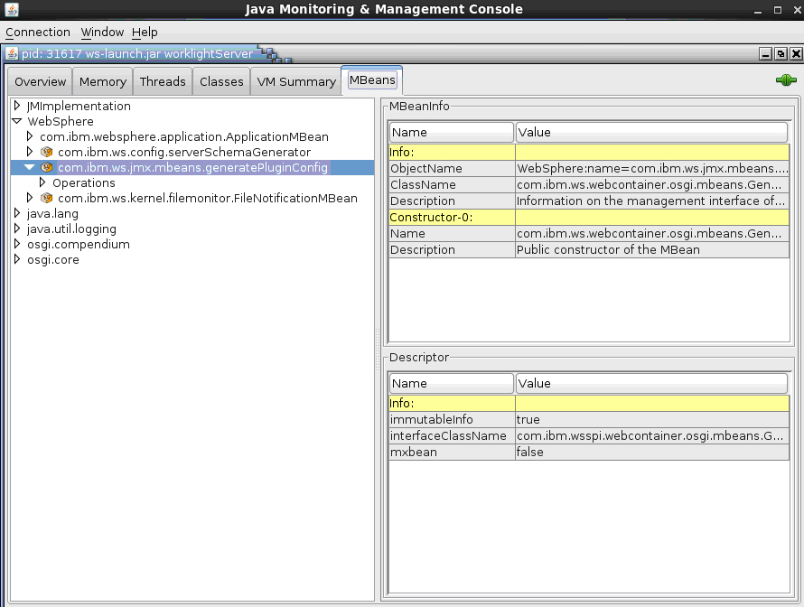

* + - 1. Select and invoke the defaultPluginConfig generation MBean operation to generate the plugin-cfg.xml file.

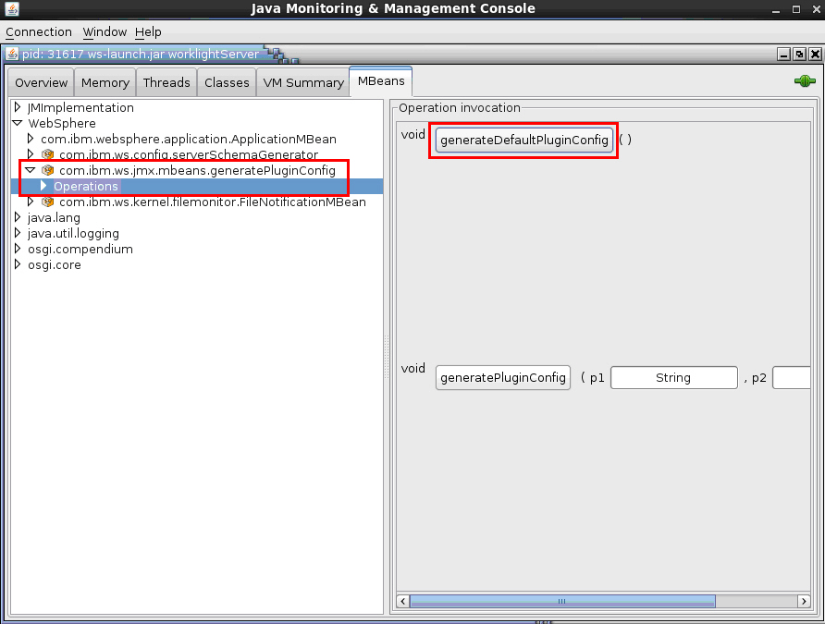

You can find the generated file in

Location: /home/ibmadmin/liberty/usr/servers/defaultServer/plugin-cfg.xml

**Note**:change **.kdb and .sth** file paths in **plugin-cfg.xml**

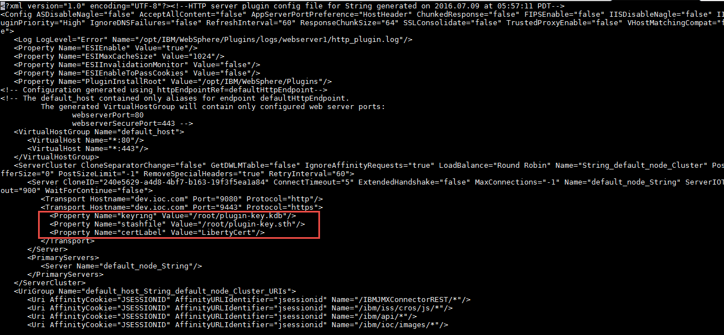

* + - Eclipse:
      1. Make sure your Liberty server is started.
      2. In Eclipse, in the servers panel, right-click the Liberty server, and then click **Utilities** > **Generate Plugin Config**.
  1. Copy the plugin-cfg.xml file to the machine that hosts the IBM HTTP Server web server, and then restart the web server to activate the settings in the file. Typically, you must enable the plug-in within thehttpd.conf file of the web server by using the LoadModule phrase, and you must specify the location of the plugin-cfg.xml file using the WebSpherePluginConfig phrase.

**On Windows:**

LoadModule was_ap22_module "path\to\mod_was_ap22_http.dll"

WebSpherePluginConfig "path\to\plugin-cfg.xml"

**On other distributed systems:**

LoadModule was_ap22_module "path\to\mod_was_ap22_http.so"

WebSpherePluginConfig "path\to\plugin-cfg.xml"

# Note:Edit http.conf file

# 

# Change plugin-cfg.xml file path to newly generated plugin-cfg.xml

# 

# References:

# Process:

# <https://www.ibm.com/support/knowledgecenter/SSHSCD_6.3.0/com.ibm.worklight.installconfig.doc/admin/t_setting_up_WL_liberty_8_5_cluster_env.html>

# Missing lib:

# <https://www.ibm.com/support/knowledgecenter/SSHSCD_6.3.0/com.ibm.worklight.installconfig.doc/admin/t_troubleshooting_ihs_startup.html>

# plugins:

<http://www.ibm.com/software/repositorymanager/com.ibm.websphere.PLG.v85>

https://developer.ibm.com/answers/questions/254828/how-to-create-plugin-keykdb-for-web-server-plug-in.html

# References:

url: <http://www-03.ibm.com/software/products/en/intelligent-operations-center>

url: <https://www.ibm.com/support/knowledgecenter/SS3NGB_5.1.0.4/ioc/install_ioc51lin.html>

for Softwares

ioc_dev_environment_installation.tar.gz:

https://delivery04.dhe.ibm.com/sdfdl/v2/sar/CM/OS/067ks/0/Xa.2/Xb.jusyLTSp44S0we8Ns91HqdCTy42wKJA4JG2GxQkZMDQsFUwq0RA2WFxZXGg/Xc.CM/OS/067ks/0/ioc_dev_environment_installation.tar.gz/Xd./Xf.Lpr./Xg.8686589/Xi.habanero/XY.habanero/XZ.8fDI8mn09tAqs43GF1DucXCk4Uo/ioc_dev_environment_installation.tar.gz

IBM_IOC_DevEd_Linux_ML.iso:

https://delivery04.dhe.ibm.com/sdfdl/v2/sar/CM/OS/064qm/0/Xa.2/Xb.jusyLTSp44S0we8Ns0IEife9Jz52l7jirJS5tv-5ka3FuzElRmhLfo6n0AI/Xc.CM/OS/064qm/0/IBM_IOC_DevEd_Linux_ML.iso/Xd./Xf.Lpr./Xg.8686581/Xi.habanero/XY.habanero/XZ.awPRuQlBu9QjfoaoC3eGkRusGOY/IBM_IOC_DevEd_Linux_ML.iso